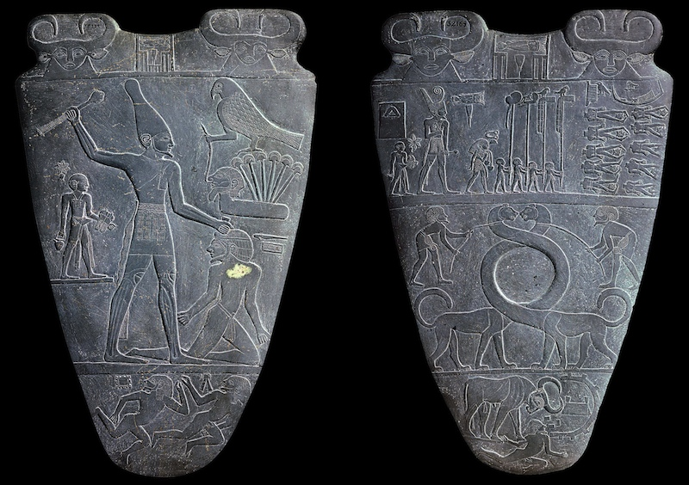
Palette of King Narmer, from Hierakonpolis, Egypt, Predynastic, c. 3000-2920 B.C.E., slate
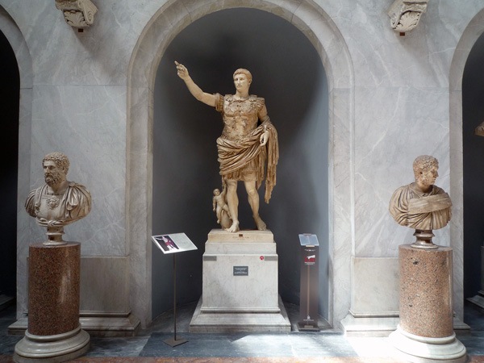
Augustus of Primaporta, 1st century C.E., marble
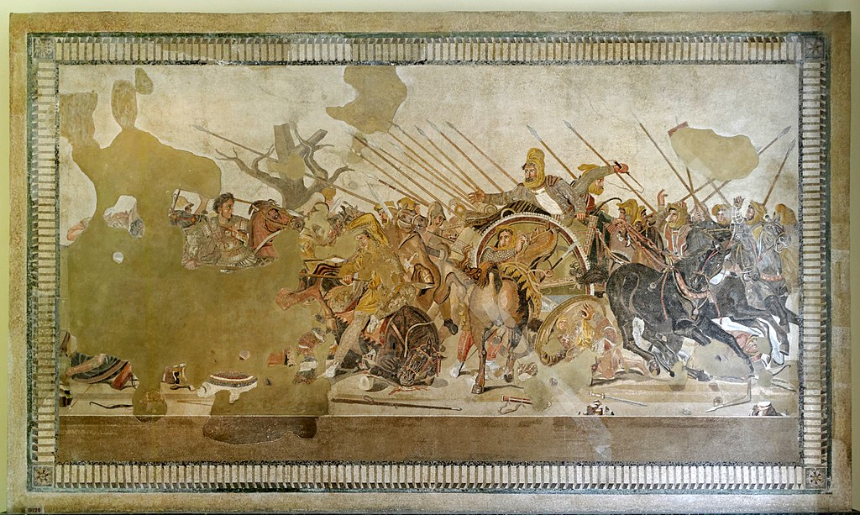
Alexander the Great (The only clear person to the left of the mosaic).
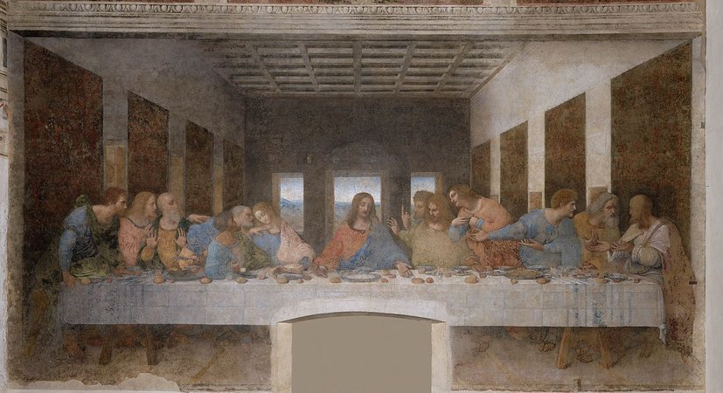
Leonardo’s ‘The Last Supper’.
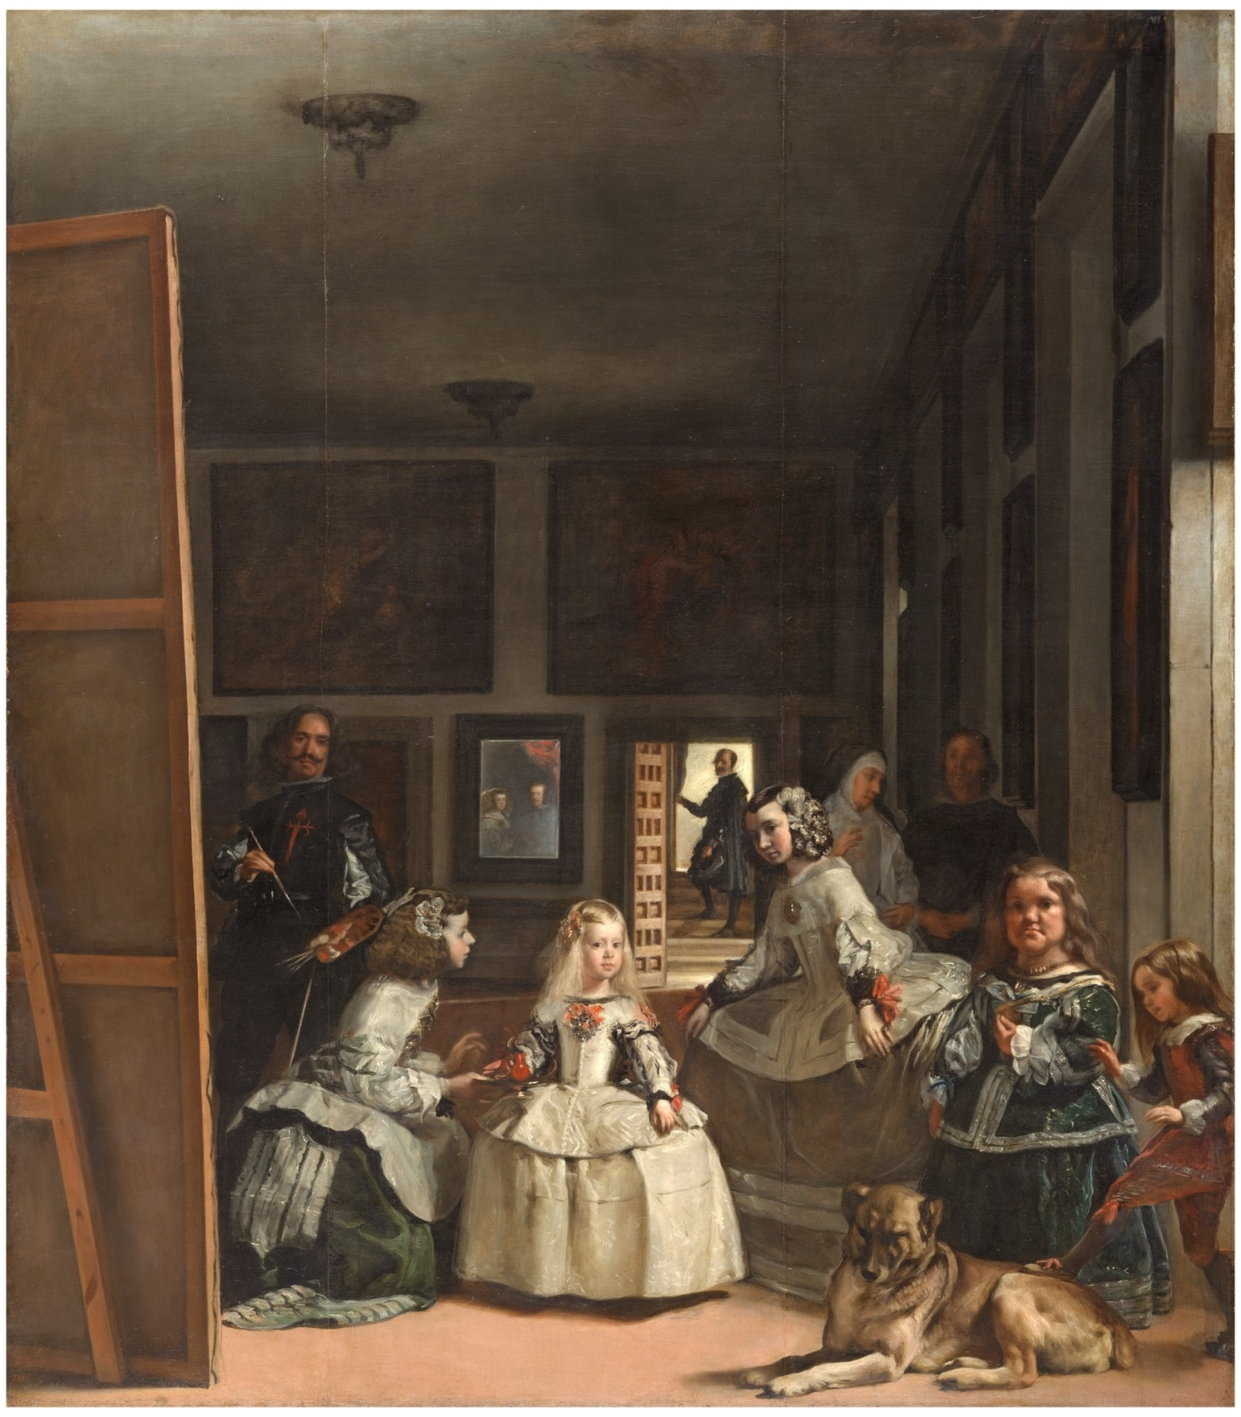
Diego Velázquez, Las Meninas, 1656
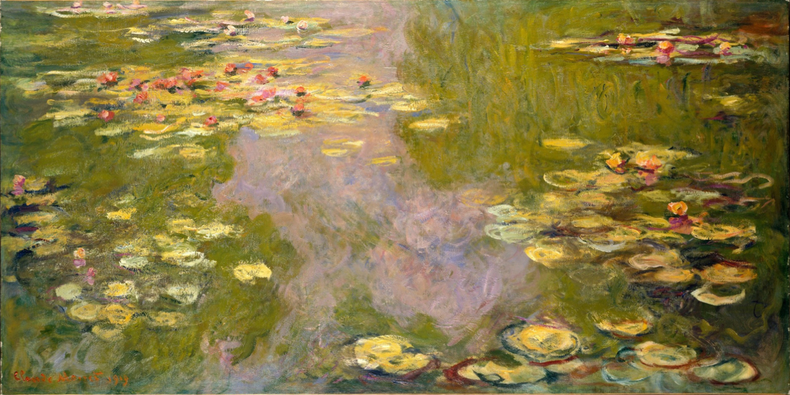
Water Lilies – Claude Monet
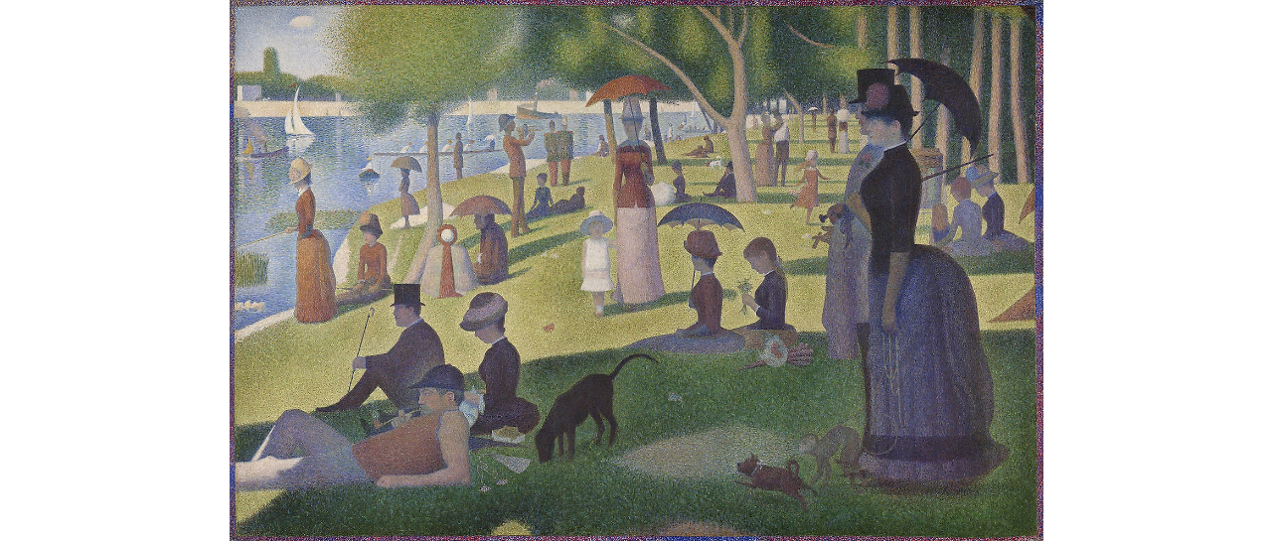
Georges Seurat, A Sunday on La Grande Jatte, 1884 (Remember Pointillism)
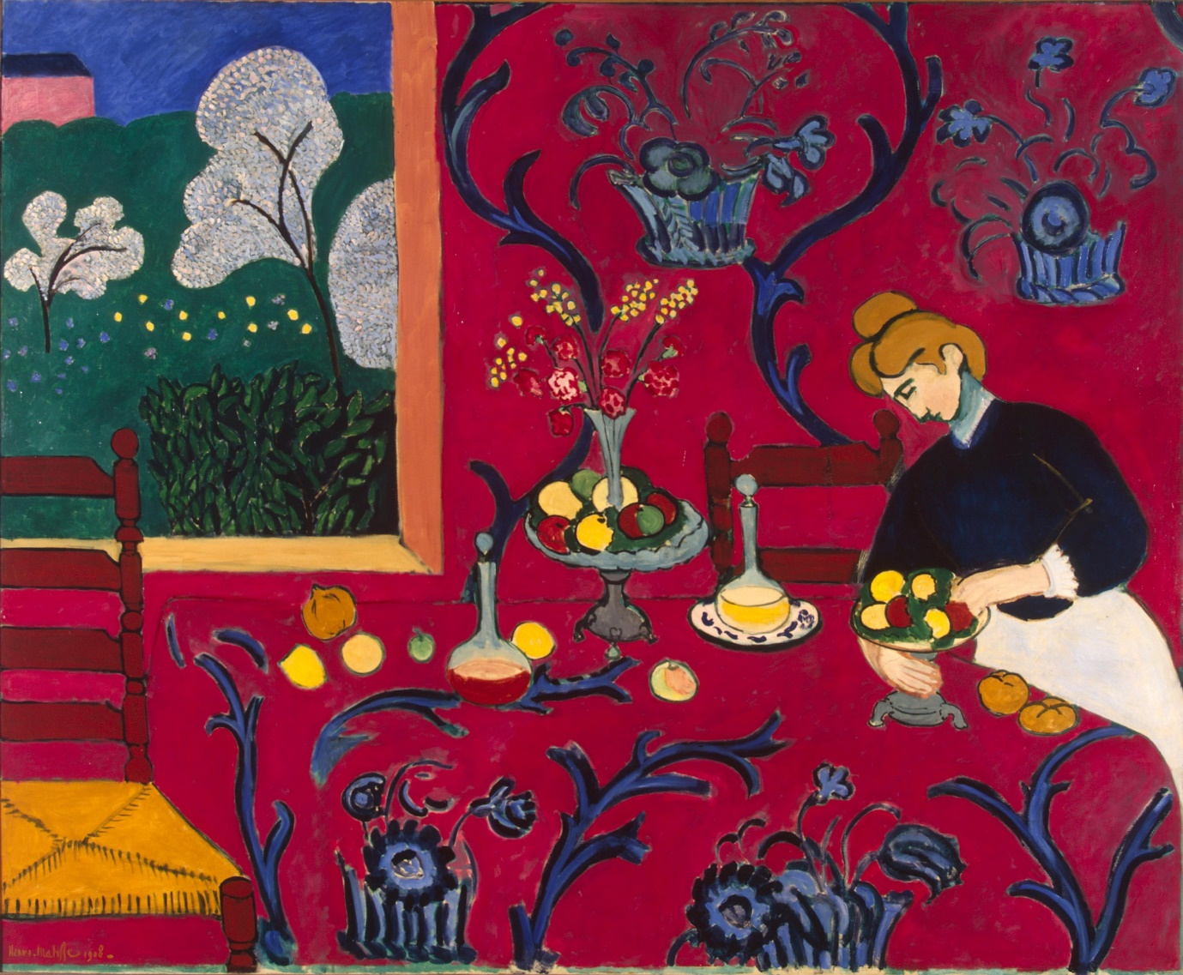
Henri Matisse, Harmony in Red/La Desserte, 1908
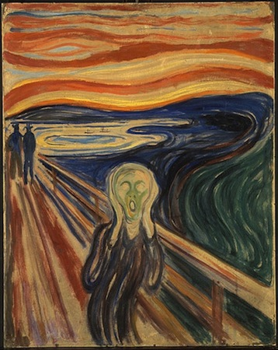
Edvard Munch, The Scream, 1910
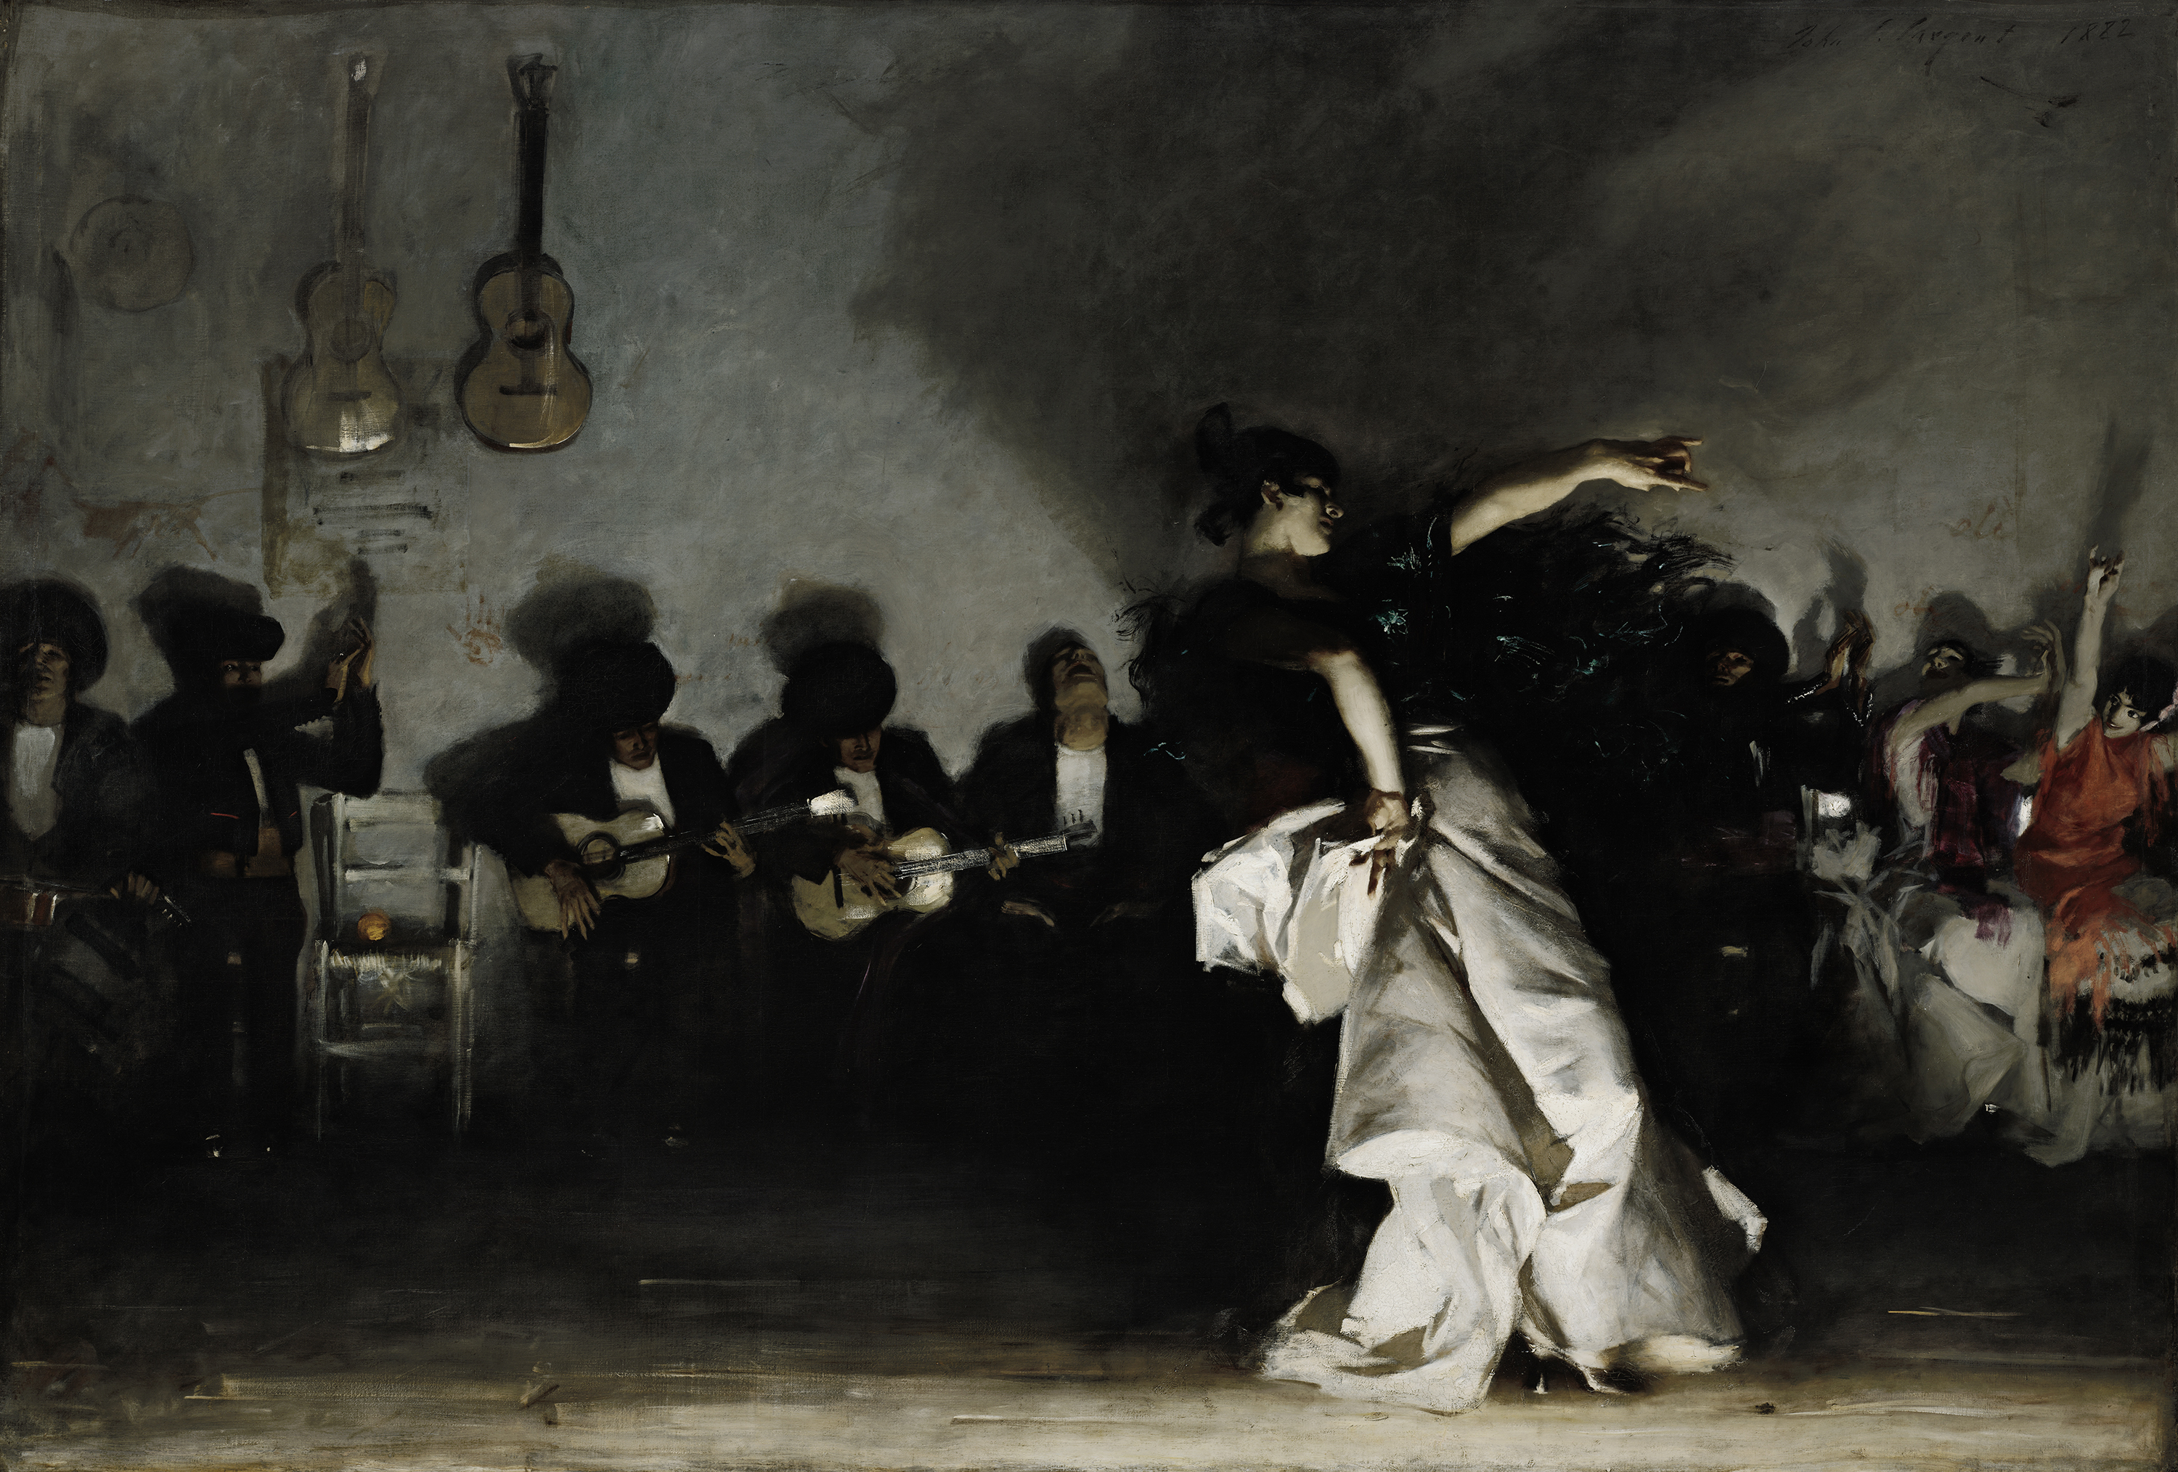

JOHN SINGER SARGENT - EL JALEO, 1882

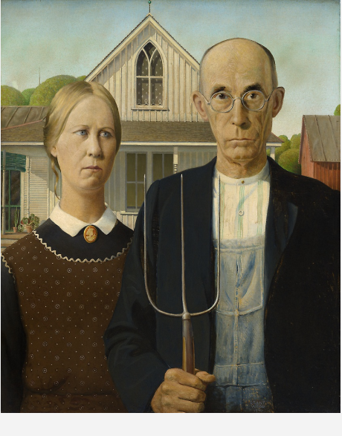
Grant Wood, American Gothic, 1930
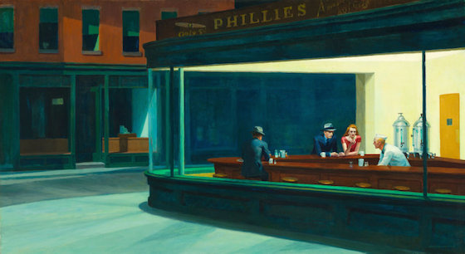Edward Hopper, Nighthawks, 1942

