English Assignment: Character and setting description
Look at the picture of the character and setting below. I would like you to describe the character of picture 1 and the setting picture 2.
(Minimum of 6 sentences on setting and 6 sentences on characters)
Picture 1: Character
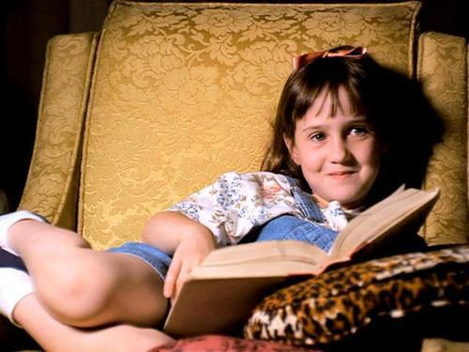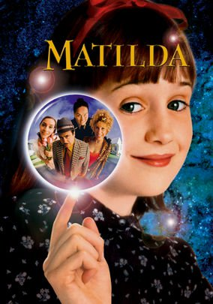
1.
2.
3.
4.
5.
6.

Picture 2: Setting (Charlie and the Chocolate Factory)
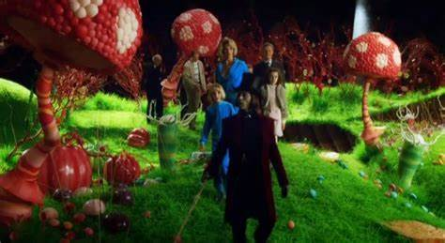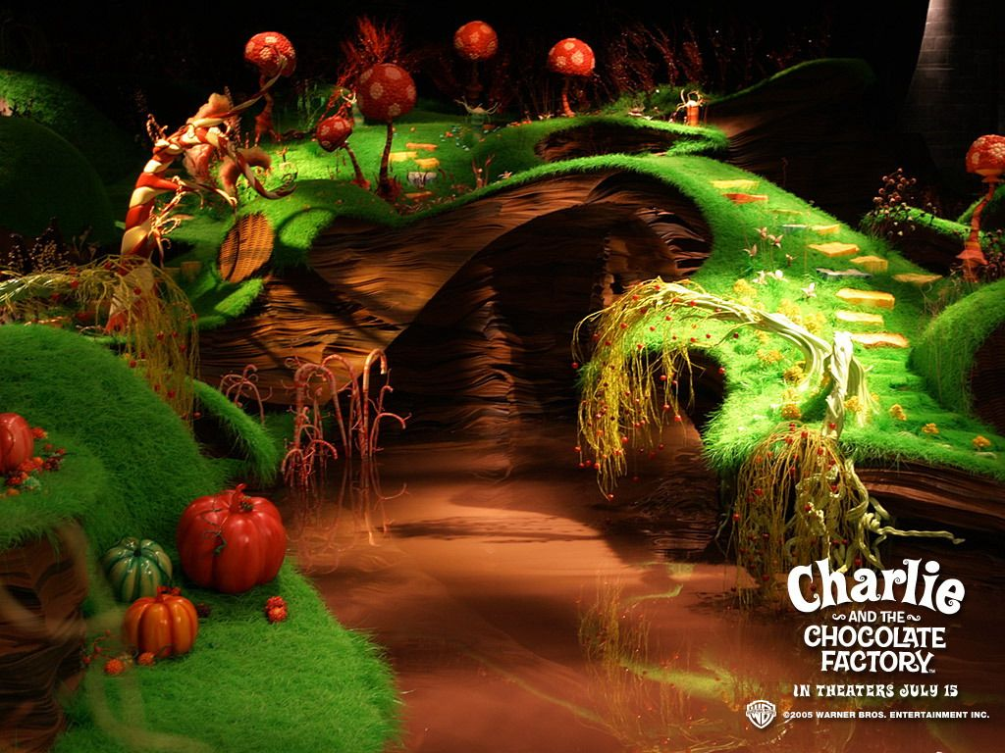

1.
2.
3.
4.
5.
6.

