This week we are asking pupils to include a National Spring Clean activity in their weekly activities. Something simple like cleaning outside your own house, going for a little walk and cleaning on the way (picking up wrappers etc) or if you are feeling adventurous you might try an up-cycling project Please take photos of any activity you do and email them to me at nicholasm2008@gmail.com .Thank you!

English
Links for the suggested books:
- Only One You by Linda Kranz
https://www.youtube.com/watch?v=v8tN1CQp_jY
- The Magic Moment by Niall Breslin
https://www.youtube.com/watch?v=bYKKPfTPG5g
- At The Beach by Roland Harvey
https://www.youtube.com/watch?v=kPL7lMLYNDk
- Sally And The Limpet by Simon James
https://www.youtube.com/watch?v=HX8vgBF1_G8

Literacy:
https://www.raz-plus.com/
https://kidlit.tv/
https://www.storylineonline.net/
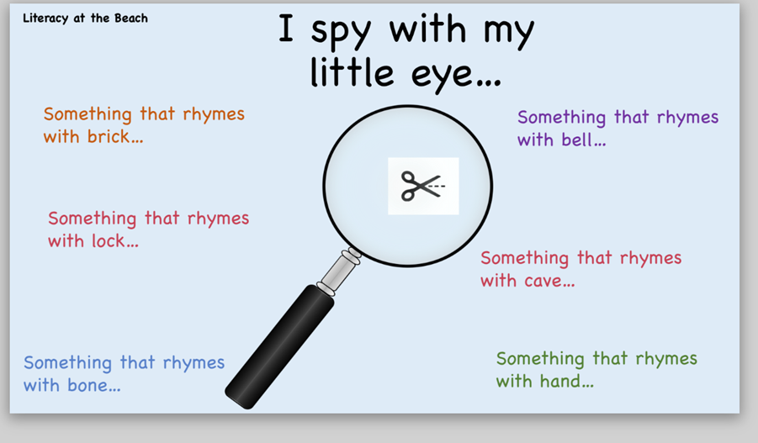
Summer poems:
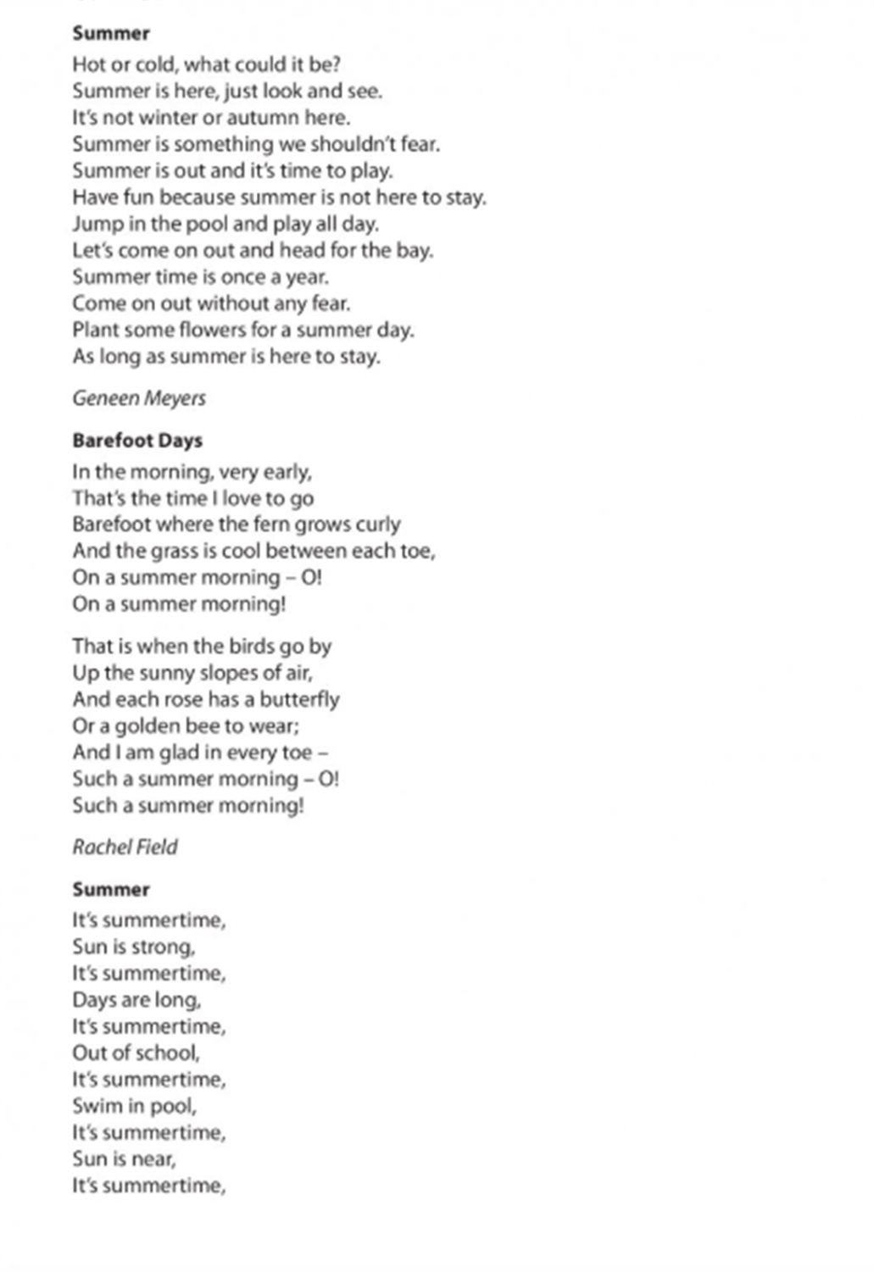
Maths

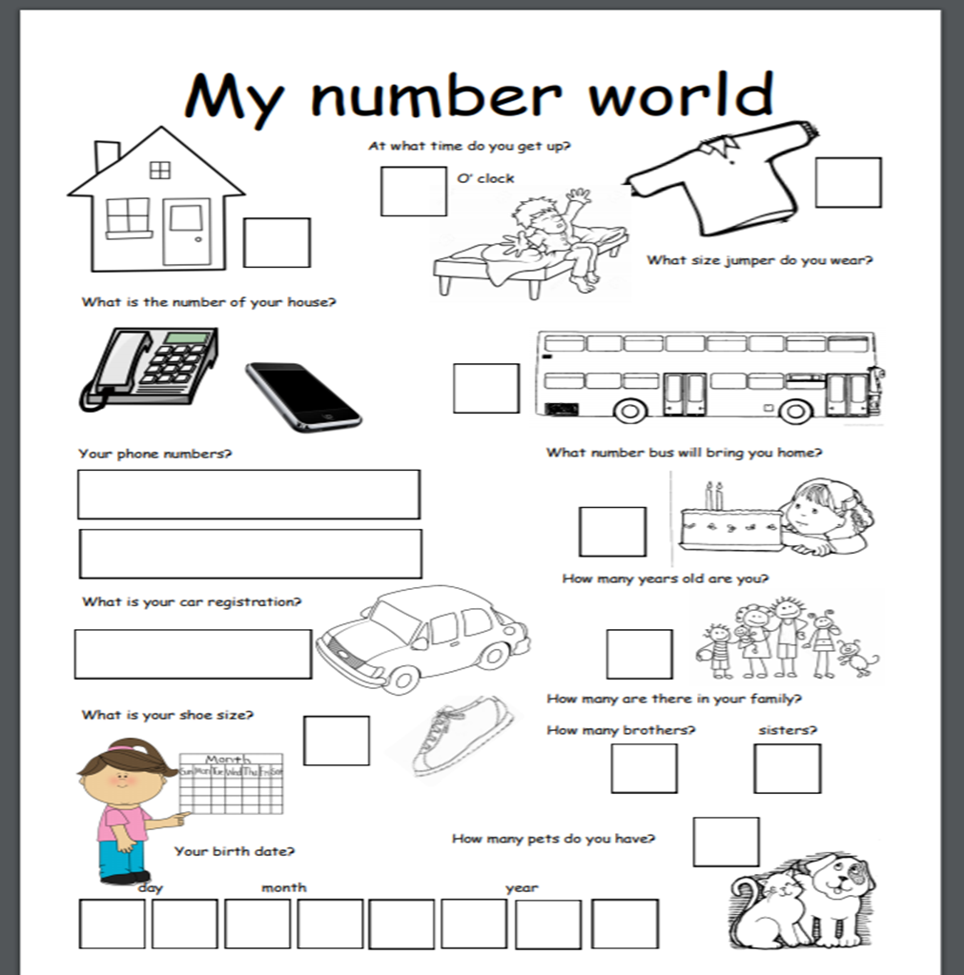

SESE:
https://classroommagazines.scholastic.com/support/learnathome/grades-prek-k.html

STEM
https://spark.adobe.com/page/7zsAKcPUQhy7S/
https://spark.adobe.com/page/yYkhBH41O2i3w/
https://pdst.ie/sites/default/files/Junior%20and%20Senior%20Infants%20-%20Sound%20Walk.pdf
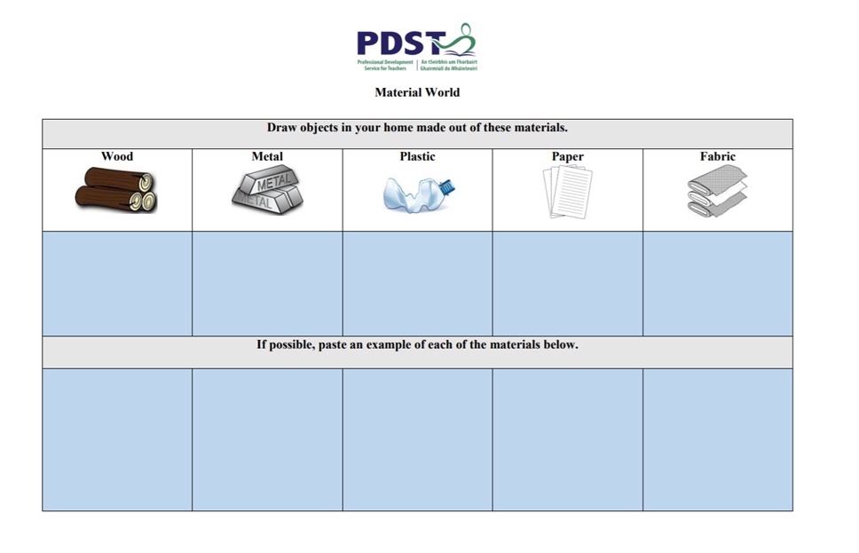

SPHE
Kindness Story:
https://www.youtube.com/watch?v=t6NUJ2JZz50

Starting a Gratitude Journal
https://www.scholastic.com/parents/books-and-reading/raise-a-reader-blog/gratitude-journal-for-kids.html

Virtual School Tours for pupils
https://www.teachpal.co.uk/virtual-trips-for-children/

Some Joyful June activities
June 15th | June 16th | June 17th | June 18th | June 19th | June 20th | June 21st
Write or draw your top five memories from school this year | Create a picture I am Thankful for | Photo Challenge – a photo that shows ‘Summertime’ | Read or say a poem | Family Sports Day | Family Baking Day – Pick a recipe and cook it at home | Call a friend or family member to say hello to them
June 22nd | June 23rd | June 24th | June 25th | June 26th | June 27th | June 28th
Doodle, colour, draw or make something arty | Do three things to bring joy to people at home today. | Photo Challenge – a black and white photo | Whisper read a poem or story | Dance to your favourite song | Creative Maths Challenge Find 10 different items in the house with numbers on them. When you have them found order from greatest to least or vice versa | Draw hopscotch outside and play it or free play

Some Creative June activities
Design a Sock Puppet | Create a Fairy or Dinosaur Garden | Design a Rock | Make something from recycled material | Paint or Dra w a picture outside
Fashion Show – Create a traditional dress from around the world | Family handprints during Covid 19 | Create something from Egg cartons | Create some window art on a window in your house (check with your parents first) | Thank you poster for all our key workers e.g. nurses, doctors, guards, shopkeepers, postmen etc.
Create a picture only using straight lines | Build a reading fort. Make it comfy and cosy and read for 15 minutes | Make up a 30 second dance routine | Invent a chocolate bar | Creative Maths Challenge Find 10 different items in the house with numbers on them. When you have them found order from greatest to least or vice versa

