English

Links for the suggested books:
- ‘Superworm’ by Julia Donaldson
https://www.youtube.com/watch?v=7Jnk3XApKBg
- ‘Mad about Minibeasts!’ by Giles Andreae
https://www.youtube.com/watch?v=SW-7MgHEZOE
- ‘What the ladybird heard’ by Julia Donaldson
https://www.youtube.com/watch?v=Eu9mPX7DuLA
- ‘Spinderella’ by Julia Donaldson
https://www.youtube.com/watch?v=Qjgp3YiaKJw
- ‘Twist and Hop, minibeast bop’, by Tony Mitton
https://www.youtube.com/watch?v=IqmABzue00A

Minibeasts nursery rhyme:

Here is the Beehive
Here is the beehive,
But where are the bees?
Hidden away,
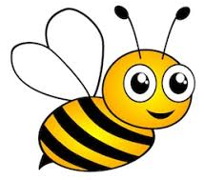
Where nobody sees.
Look and you’ll see them,
Come out of the hive.
One, Two, Three, Four, Five.
BUZZZZZZZZZZZZZZZ

Maths
Minibeasts themed counting songs:
- The Bees Goes Buzzing
https://www.youtube.com/watch?v=bWUgZm_AE64
- Counting With Bugs
https://www.youtube.com/watch?v=F10LRMyMw5E&list=PL773dg5WAbfPXBpjLK2puuJMOt1DVJFzA
- The Ants Go Marching
https://www.youtube.com/watch?v=Pjw2A3QU8Qg&list=PL45e_Hn__7SQ4VQZhX5RpmPdAi6bpElb9&index=8

PE
Minibeasts themed movement break:
https://www.youtube.com/watch?v=hUbYq93cYdE&list=PLVKi6dgrGk9QJbIfW8VIfarxy02yrWGPC&index=2

Cosmic Yoga, Enzo the Bee
https://www.youtube.com/watch?v=uyj5LooYWyg

Music
Minibeasts songs:
- Sing-a-long ‘If I Were A Mini Beast’
https://www.youtube.com/watch?v=-eajwaH0_2c
- Bug n’ Roll
https://www.youtube.com/watch?v=oybEMWW23uU
- Wiggly Woo
https://www.youtube.com/watch?v=vdWsez-CD5o
- Creepy Crawlies and Itchy Things
https://www.youtube.com/watch?v=wAjCCUoFAeI

Science
Minibeast hunt activities:
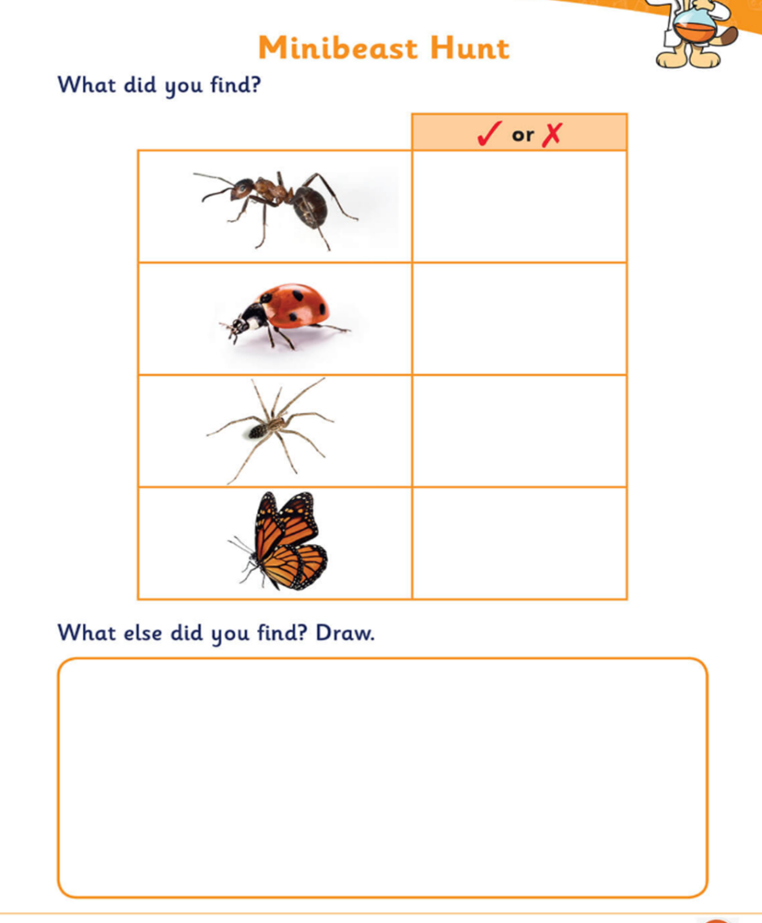

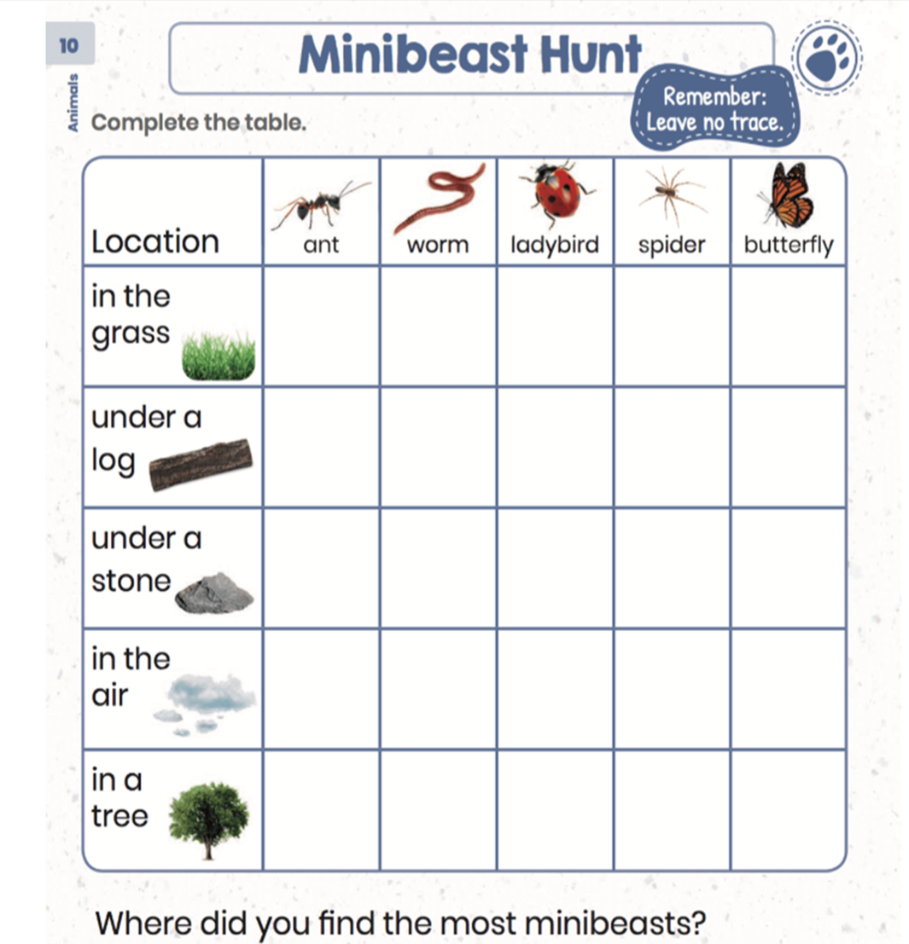

Geography
Explore a soil environment activity:
