English

Links for the suggested books:

- Ten Magic Butterflies by Danica McKellar
https://www.youtube.com/watch?v=kBi_RoXKVo0

- My Oh My What a Butterfly by Dr. Seuss
https://www.youtube.com/watch?v=sIQH6yfp93I

- The Amazing Lifecycle of Butterflies by Kay Barnham
https://www.youtube.com/watch?v=aBkqnNOzYc4

- Charlie the Caterpillar by Dom DeLuise
https://www.youtube.com/watch?v=gEn7zOf6PVo

Minibeasts nursery rhymes:
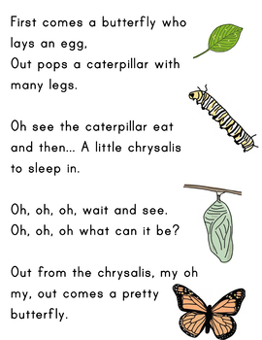
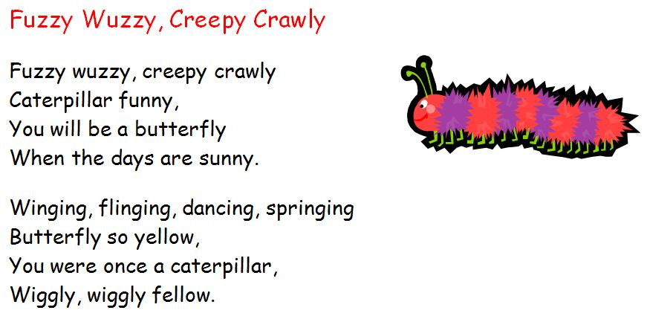

Maths
Minibeasts themed counting songs:
- Five Little Caterpillars
https://www.youtube.com/watch?v=v5ZCw9cUEq0

PE
Minibeasts themed movement break:
- The Butterfly Song
https://www.youtube.com/watch?v=1EQeYA5Qbic
- Cosmic Yoga, The Very Hungry Caterpillar
https://www.youtube.com/watch?v=xhWDiQRrC1Y

Music
- Hungry Caterpillar with lyrics (Sing-a-long)
https://www.youtube.com/watch?v=_-gNaNOWdg8

The following are some suggestions you might do next week. Please feel under no pressure, pick and choose activities that suit you. (Below timetable please see instructions on how to make your own Glitter Jar and Squishy Worry Ball)
Monday; | Tuesday; | Wednesday; | Thursday; | Friday;
Yoga;  Cosmic Yoga;  Complete ‘The Very Hungry Caterpillar’ Yoga video which is available on the website.  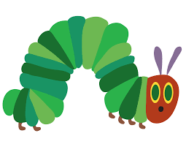 | Yoga;  Cosmic Yoga;  Complete ‘We’re Going on a Bear Hunt’ Yoga video which is available on the website.  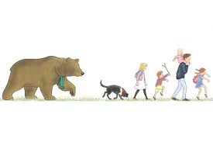 | Yoga;  Cosmic Yoga;  Complete ‘Co Co The Butterfly’ Yoga video which is available on the website. | Yoga;  Cosmic Yoga;  Complete ‘Popcorn and the Pirates’ Yoga video which is available on the website. | Yoga;  Cosmic Yoga;  Complete ‘Pedro The Penguin’ Yoga video which is available on the website.
Story Time;  Listen to the story ‘The Huge Bag of Worries’.  Draw some pictures of things that worry you in the worry bag and discuss them with your parents. | Mindfulness Colouring;  Play some relaxing music and chill out while you colour! Colour the first letter of your name and your age! | Story Time;  Listen to the story ‘Don’t Worry William’.  Draw a picture of your favourite part of the story and discuss it with your parents. | Glitter Jar;  Follow the instructions on the back of the sheet to make your own glitter jar! If you feel worried, give the jar a shake, watch the glitter swirl around, and then settle calmly at the bottom. | Balloon Worry Ball;  Follow the instructions on the back of the sheet to make your own worry ball! If you feel worried, give the ball a few squeezes, this will help take your worries away!
Mindful Listening;  Listen carefully with your eyes closed to any sounds you can hear. After 1 minute open your eyes and write down everything you heard. | Teddy Breaths;  Lie on your back on the floor and place a teddy on your tummy. Breathe in and out slowly and try to concentrate on the way your teddy rises and falls when you breath. | Feel Your Heart;  Run on the spot/ do jumping jacks for 1 minute. Place your hands on your heart and feel it beating very quickly. Breath slowly and deeply, and feel your heartbeat slow and calm. | Thankful Thursday;  Draw a picture of/ write a list of all the things that make you happy and that you are thankful for! (family, friends, pets, nature etc.) | Feelings Friday;  Take a moment to think about how you are feeling. What words describe how you are feeling? Draw a picture and talk to your parents about it.
