Jungle stories, rhymes and songs
- Story ‘The Selfish Crocodile’
https://www.youtube.com/watch?v=0-NhjfJ_RZI
- Story ‘Giraffes Can’t Dance’
https://www.youtube.com/watch?v=vZjsLK5vwNU
- Song ‘Walking in the jungle’ (Super Simple Songs)
https://www.youtube.com/watch?v=GoSq-yZcJ-4

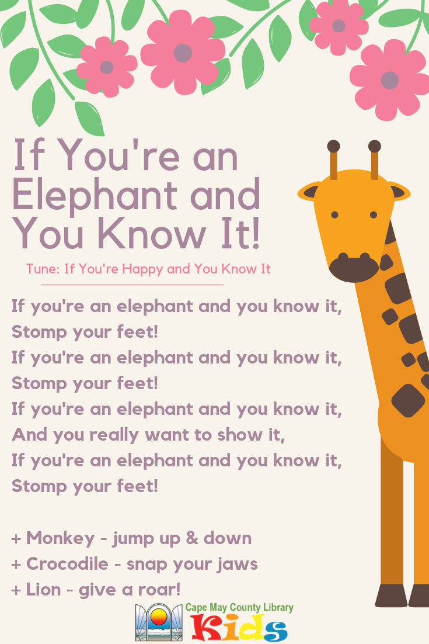

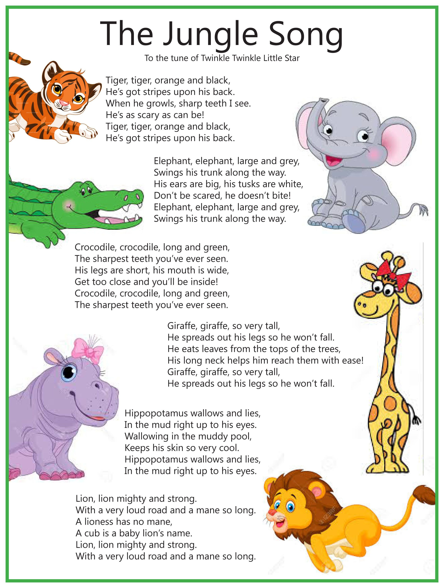

Maths
Nice online game for interpreting data
http://flash.topmarks.co.uk/4771

Some counting songs
- Counting in the jungle
https://www.youtube.com/watch?v=6Q-bNBt4jA8
- Jungle animals counting song
https://www.youtube.com/watch?v=CbjyQRrM-jI
- The ants go marching one by one
https://www.youtube.com/watch?v=Pjw2A3QU8Qg

Gaeilge
Some lovely playground games (Cluichí clóis), which are also great active flag ideas
- https://www.youtube.com/watch?v=wlPiEEzrtX8
- https://www.youtube.com/watch?v=_HtJxVT8jcY&t=7s
- https://www.youtube.com/watch?v=HRfN5mLqHdQ

PE
A few more daily active breaks….
- We’re going on a lion hunt
https://www.youtube.com/watch?v=03i5v1PS7P4
- Song ‘Down in the jungle’
https://www.youtube.com/watch?v=dFiqiQlHPwU
- And of course….. ‘Elephants have wrinkles’
https://www.youtube.com/watch?v=cRvMB9zJvsg

History
- If you would like to be a historian and document a part of your life during lockdown -
https://tipperarystudies.ie/life-in-lockdown/

Science
All Things Animals Tv have some lovely short factual videos on various jungle animals
https://www.youtube.com/watch?v=CP5uJVpHrVw (Elephant)
https://www.youtube.com/watch?v=qnaXJf_yaj8 (Lion)
https://www.youtube.com/watch?v=_vii-jpTjDg (Hippo)

And a few nice little extras……
