Mathemagic Page 107: Do question 3 (a, b & c).
There is an assignment for this work. Please enter your answers there.
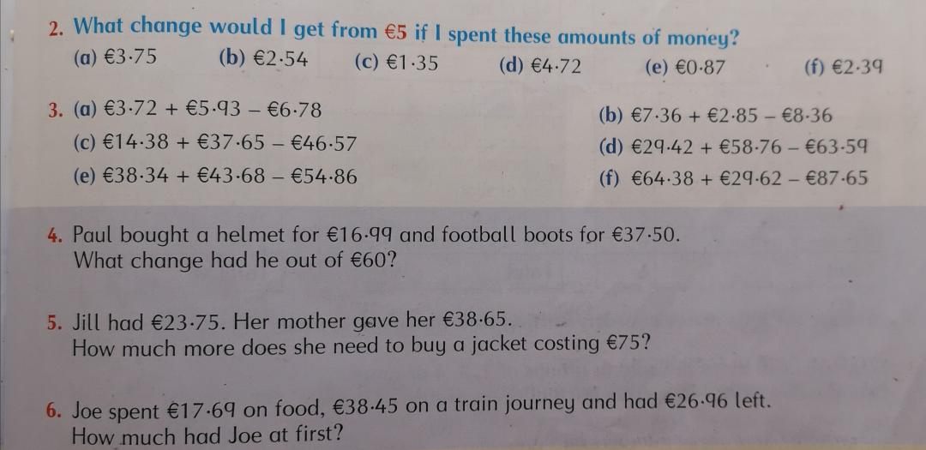

Mathemagic Page 108: Do question 3, all parts.
There is an assignment for this work. Please enter your answers there.
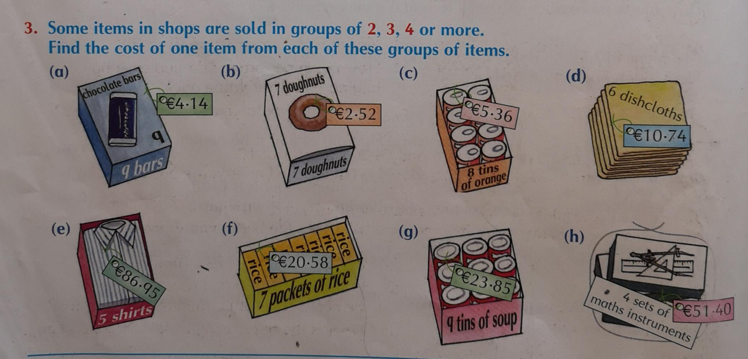

Scroll down to the next page for Mathemagic page 109

Mathemagic Page 109: Do question 2 & 3 all parts.
There is an assignment for this work. Please enter your answers there.
