Maths Work 6th Class
May 18th -22nd
*Maths is an area that it is important to have a good foundation in next year, therefore we would like you to give it a bit of time over the next few weeks. Please spend 45min a day at your maths and if you are finding it hard you may need to spend a little longer. If you are finished work early one day you could start on the next day’s work. Highlight the points you can complete at the bottom as you move through the week.

We are starting a new topic in maths this week, please ask someone at home to help you with it and go over the problems with you.

*We will be using tutorial videos from CJ Fallon again this week, you should be able to access these by clicking on the links or go to the CJ Fallon website. If you had trouble viewing them last week will you please message me.

Topic for the week- Lines and angles, weight.
You will need a protractor and compass for maths this week. If you are stuck I have an image of a protractor at the end of this document, cut it out and do your best with it, might help if you stick it on hard card. If you don’t have a compass, watch this YouTube video and it might help-
drawing a circle without a compass.

Monday and Tuesday - Lines and Angles, Mathemagic ch.25
New Wave Mental Maths- week 31 Monday and Tuesday. Correct last week’s work if you haven’t already done so and upload a picture of the corrected work to assignments (New Wave Mental Maths week 30 completed and corrected). The answers will be in the maths channel (that is in the list under General, Class news etc. click on maths and scroll up through the posts.)

Lines and angles:
Watch tutorial 24, you should know the meaning of the following afterwards- right angle, obtuse angle, acute angle, full rotation, straight angle etc. try and make the angles yourself using your arms. Make notes and learn what each angle means.
Tutorial 24

Remember : acute angle <90° , right angle = 90° , 180° > obtuse angle > 90° (obtuse angle is between 90° and 180°), straight line= 180°, reflex angle > 180°, full circle = 360°, full rotation= 360°, half rotation= 180°

Try the following online challenge to see if you understand rotations and can make a good guess at measuring them. Note the red line, that gives you a hint as to the size of the rotation, take a few goes at it if you need to, it is tricky.
Tutorial 28

Watch tutorial 25 to revise how to draw an angle. You will have covered this last year but may need to revise it. Try drawing a few angles if you need to, there are plenty questions related to drawing angles in mathemagic chapter 25.
Tutorial 25.

Watch tutorial 29 to learn how to draw a reflex angle. Try drawing a reflex angle of 220° and 340° . Upload them to Monday and Tuesdays maths homework in the assignments tab.
Tutorial 29

Triangle- all the angles of any triangle you draw when added together have to equal 180°. Watch this video clip to prove it:
All the angles of a triangle add up to 180°
Try it by drawing a random triangles yourself (remember use a ruler, the sides have to be straight), label the angles A, B and C. Tear or cut off the angles and try placing them together in a straight line, remember you have to put the pointy angle parts together. The same experiment can be used for any 4 sided figure to prove the 4angles in any 4 sided figure add up to 360°. Try it, draw and irregular 4 sided figure, name the angles A,B,C and D. Cut out or tear off the angles and see if you can get them to fit into a circle (360°) post a picture of both (triangle and 4sided figure) to assignments under Monday and Tuesdays maths homework.

Watch tutorial 26 to learn how to draw a triangle given two sides and an angle. Draw a triangle with sides 4cm and 5cm and the angle between the sides is 70°. Upload a picture of the triangles to ‘Monday and Tuesdays maths homework’.
Tutorial 26

Watch tutorial 27 to learn how to draw a triangle given two angles and a side. Draw a triangle with a side 4cm and angles of 40° and 55° at either side. Upload a picture of the triangles to ‘Monday and Tuesdays maths homework’.
Homework to upload in assignments under ‘Monday and Tuesday’s maths homework’:
- 1. Draw 2 reflex angles (tutorial 29)
- 2. Picture of 3 angles in a triangle adding up to 180° and 4 sides of a quadrilateral adding up to 360° (YouTube video).
- 3. Picture of the 2 triangles drawn after tutorial 26 and tutorial 27.
Tutorial 27

Types of triangle:
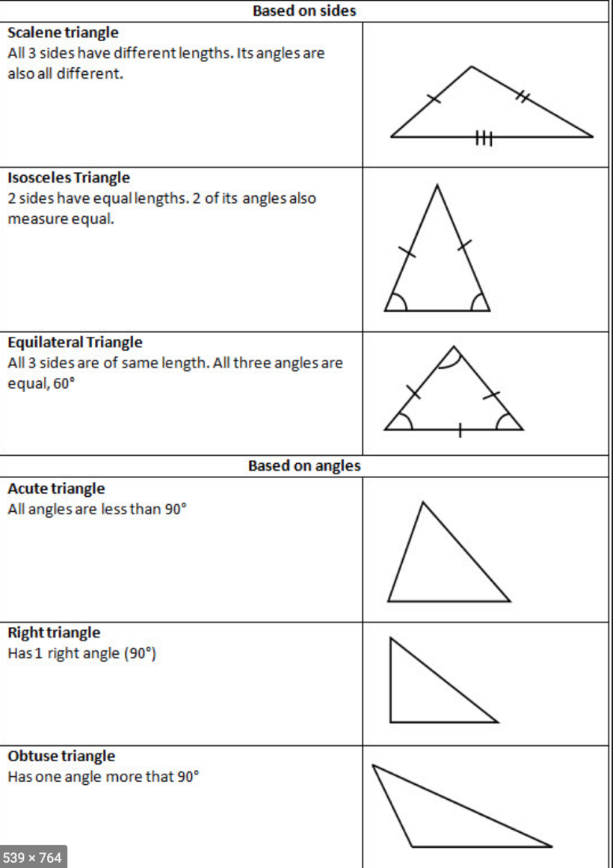

Wednesday and Thursday - Measures, Weight mathemagic ch.34
New Wave Mental Maths- week 31 Wednesday.

Revise over and finish any activities you didn’t get finished on Monday and Tuesday.

Weight:
Look at page 143 mathemagic, try activity 2 and 3 orally (you do not have to write it out.)
Complete the following tutorial.
Tutorial 97

Remember there are 1000g in a kg. Learn off the following;
750g=0.75kg= ¾ kg
500g = 0.5kg= ½ kg
250g= 0.25kg = ¼ kg

Remember there are 1000kg in a tonne
750kg= 0.75 tonne = ¾ tonne
500kg= 0.5 tonne = ½ tonne
250kg= 0.25tonne = ¼ tonne

Learn the following:

To change from grammes to kg divide by 1000
To change from kg to tonne divide by 1000
To change from tonne to kg multiply by 1000
To change from kg to grammes multiply by 1000
Remember to multiply by 1000 move the decimal point 3 places to the right (number is getting bigger)
To divide by 1000 move the decimal point 3 places to the left (number is getting smaller).

Complete the following:
Mathemagic page. 144: Q3, Q4 a-f, Q5 i
Mathemagic page 145: Q1 m-r and Q4
Correct the above, the answer page is in the maths channel, please correct before you upload it to your assessment.

Friday- Measures, Weight mathemagic ch.34

New Wave Mental Maths- week 31 Friday review, complete the activity in the book and then enter the answers into the Friday assignment . It is important to type the answer exactly as you wrote it in the book, if you did not need to name the answer in the book DON’T name it in the quiz. If the book has 0.___ kg written in and the answer is 0.5kg, all you have to add is 5,just type 5 in the answer box in the quiz. The quiz is very exact, if you put in an extra space or . it will mark it incorrect.

Complete the following 12 questions from Figure it Out pg. 73, when you are finished look at the answer page I have in the maths channel and see if you got the problems correct, upload a photo of your finished corrected work to the assignments tab. If you were unable to do a question, look at how and did it and see if you can work out where you went wrong.

By the end of the week you should be able to complete the following tick them off as you can complete them:
Chapter 6 page 25 Mathemagic- Lines and angles.
- Do I know what the following are: right angle, obtuse angle, acute angle, full rotation, straight angle etc
- Do I know what a rotation is.
- Can I make a good guess at the size of angles / rotation (say if an angle is acute, obtuse, right angle etc. )
- Can I measure a rotation/ angle (revision from last year.) (Mathemagic pg. 25)
- Can I draw angles using a ruler, pencil and protractor (Mathemagic pg. 26)
- Can I draw a triangle given two sides and one angle (mathemagic pg. 26)
- Can I draw a triangle given one side and two angles (mathemagic pg. 26)
- How many degrees in a triangle? Prove it? (Mathemagic Pg 27)
- Can you find the 3rd angle in a triangle if given 2 of the angles. (Mathemagic pg27) Remember all angles have to add up to 180° mathemagic pg 27 Q2
- Do I know the three types of triangle- isosceles, scalene and equilateral.
- What do we know about the sum of the sides of any 4 sided figure. – they have to add up to 360°
- Area of a triangle- ½ base X perpendicular

Chapter 34 Mathemagic- Weight
- Do I know suitable instruments to measure items such as a leaf, an elephant, a car etc.
- Can I change g- kg- tonnes and back again.
- Can I make a good guess at the weight of items.
- How many grammes in a kg, How many grammes in .5kg, .75kg etc. (pg. 144 mathemagic)
- Can I find what fraction of a kg a certain amount of grammes is (pg.145)
- Can I add, subtract, multiple and divide weights. (bring to the same name before adding and subtracting. )
- Can I put weights in order of size pg.145
- Can I work out problems involving weights and shopping (pg.146)

*If you would like extra revision on lines and angles or weight, the CJ Fallon website will give you free access to Figure it Out, Busy at Maths and the Shadow Book for mathemagic. All these have chapters related to lines and angles and weight with plenty activities and if you need to answer pages to check your work just message me and I will send them on.

