5th class work – Tues. 5th - Fri 8th May 2020
Remember: This page simply lays out what work you need to complete. For Maths and Creative Writing you need to go the Assignments section of Teams and do your work there. It saves automatically each time you work on it. So, complete all the Maths and Creative Writing work first before you click submit.
Don’t forget to keep up your Accelerated Reading effort.
https://ukhosted11.renlearn.co.uk/2935049/default.aspx

Tuesday 5th May
- Abair Liom – page 163 – Caitheamh aimsire (Pastimes). Take 4 to learn each day starting today with peil, sacar, rugbaí, iománaíocht. Read the phrases/sentences/questions on top half of the page and practice them out loud. You might get someone at home to ask and answer with you if possible. We are taking a break from Fuaimeanna & Focail this week!

- My Spelling Workbook – continue unit 15 – next four spellings (should be Sensible/audible/legible/divisible) and next activity No. 6. Spend 10 minutes on the wordsearch

- Handwriting - complete half of the next page you are on in Go With the Flow

- Creative writing – Take a look at the image included below. Discuss what you can see. Brainstorm a story idea based on this picture and make a plan for your story. Outline characters, setting, plot, problem, how the problem will be solved and an ending. (this work needs to be submitted by Friday evening)
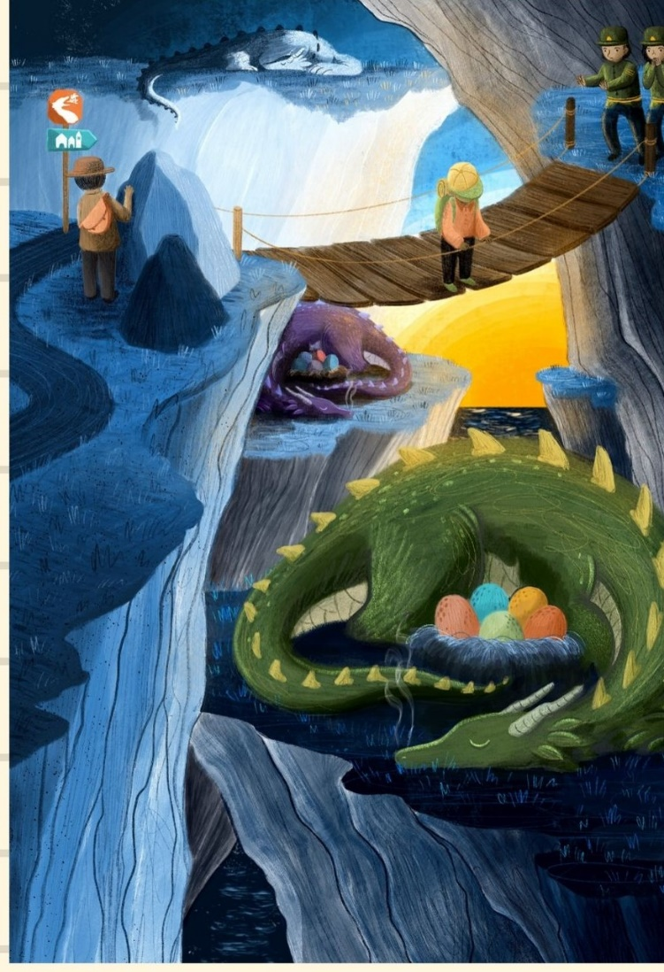
- Mapskills - Benelux countries – page 40. Examine the map on page 40 showing the countries of Belgium, Netherlands and Luxembourg and read the fast facts on page 40 and 41. Pick 5 facts to memorize!

- Maths - Mathemagic Book – Page 93 Question 1 & 2. I have provided a little help in the ‘Maths Help’ file if needed. There are some YouTube clips explaining how to do these questions.
(Maths work needs to be submitted on Friday. Each day your work in this assignment will be saved automatically. So, you can wait until all the maths work is completed before submitting)

- Active at Home Week: Have you completed your challenge card yet? If not, don’t worry, it’s not too late! Details on Ballina Primary School website.
5._challenge_chart__schools_working_towards_asf__fillable_pdf.pdf

Wednesday 6th May

- Abair Liom – page 124. Examine the poster and pictures. Read all the words and phrases. Can you remember how to say referee/players/spectators as gaeilge? Go back to page 163 from yesterday. Test yourself on the 4 you learned and take the next 4 to learn now – camógaíocht, cispheil, leadóg, snámh. Look back over the phrases at the top of the page.

- My Spelling Workbook - unit 15 – next 4 to learn – forgotten, separate, cough, laugh. Complete no. 7 and continue with wordsearch.

- Handwriting - complete second half of the page from yesterday in Go with the Flow

- Creative writing - begin to write your story based on the picture with the dragon. Use your plan from yesterday to help you. Don’t forget paragraphs for each idea and go back and edit your work for mistakes (capital letters, full stops, spelling)

- Mapskills - do you remember the 5 facts you learned yesterday? Complete Activity A on page 41

- Maths - Mathemagic Book – Page 93 Question 3 & 4. I have provided a little help in the ‘Maths Help’ file if needed. There are some YouTube clips explaining how to do these questions.
(Maths work needs to be submitted on Friday. Each day your work in this assignment will be saved automatically. So, you can wait until all the maths work is completed before submitting)

Thursday 7th May

- Abair Liom - pg. 163 – learn next 4 - gleacaíocht/lúthchleasaíocht/rothaíocht/cearáite. Revise questions at top of page again.

- My Spelling Workbook - unit 15 next 4 words – draught/paragraph/photograph/atmosphere. Complete No. 9 and wordsearch if not already completed.

- Creative writing - complete story and edit it. Don’t forget to give your story an interesting title. Read it to someone in your family!

- Mapskills - complete Activity B on page 42

- Maths - Mathemagic Book – Page 93 Question 5a,b,c,d. I have provided a little help in the ‘Maths Help’ file if needed. There are some YouTube clips explaining how to do these questions.
(Maths work needs to be submitted on Friday. Each day your work in this assignment will be saved automatically. So, you can wait until all the maths work is completed before submitting)

Friday 8th May

- Abair Liom - page 163 – learn next 4 - marcaíocht ar chapall/cluiche/traenáil/foireann. Read page 125 – an ticéad and complete the questions to the best of your ability.

- My Spelling workbook - complete the rest of the spellings, activity no. 10 and any other incomplete activities from unit 15.

- Creative writing/art - design an illustration to go with your story. It could be a front cover, character, place, action scene or group of scenes. Take a picture of your completed story and illustration and send to me for correction. I look forward to reading it!

- Mapskills - complete page 43 – Try at Home page. How much of it can you do without having to look back?!

- Maths - Mathemagic Book – Page 93 Question 6. I have provided a little help in the ‘Maths Help’ file if needed. There are some YouTube clips explaining how to do these questions.
(Maths work needs to be submitted on Friday. Each day your work in this assignment will be saved automatically. So, you can wait until all the maths work is completed before submitting)

