5th class work – Mon. 18th - Fri. 22nd May 2020
Remember to check when your assignment is due for.
Remember – Every page you need has been provided here on the school website.
Or, if you click on Files you will find all the folders containing the work we have given you by the week. Inside those you will find folders for each subject. These folders contain the pages you need. 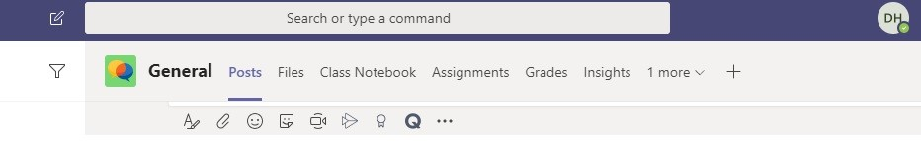
Keep up your Accelerated Reading effort.
https://ukhosted11.renlearn.co.uk/2935049/default.aspx

Monday 18th May
Gaeilge:
- Fuaimeanna agus Focail - aonad 29 page 88 – list 1 (learn 4 words). Complete A and B in workbook.
- Abair Liom – read page 132 comhrá – practice your reading aloud with someone at home if you can. No written work needed here, just reading.
The Abair Liom page can be found under ‘Files’ in the folder for this week’s work.

English:
- My Spelling Workbook – unit 16 page 62 – continue to learn next four spellings (fabulous-numerous) and complete activity No. 6 in workbook. Spend 10 minutes on the word search.
- Handwriting - complete half of the next page you are on in Go with the Flow

Geography:
- Map Skills – unit 2 – Europe – The European Union (page 8) Read the fast facts on page 9 and complete Activity A in your workbook. Look at the list of E.U countries on page 10 and their capitals. You are going to learn all 28 of these capitals this week, taking 7 every day. So today learn Austria to Denmark. There will be a quiz assignment on Friday on this.
- (Múinteoir David’s class may have this done. Check. If it is not done in your workbook for whatever reason, please complete it. The assignment for this will be open to you as well as to the other class. Have a go and see how much you remember).
Click on this link to play a capitals of Europe game.
https://world-geography-games.com/capitals_europe.html

Maths:
Money:
https://www.youtube.com/watch?v=7fVnbgc7Ft0 This video shows why euro coins have different backs and how they travel around Europe.
https://www.youtube.com/watch?v=rFDsSMDeV3w This video shows how the €2 coin is made.
https://www.youtube.com/watch?v=3hrx8WK2TH0 This video talks about the security features and other surprising things you will find on European bank notes.
So, the task for today is to watch these videos. Then in the assignment section list 10 things you learned about the euro that you did not know before.

Art:
This week I would like to borrow an idea from Carrigaline Educate Together School. This link takes you to an Irish Examiner article about their project. I wonder can you too re-create the old (or modern) masterpieces of art?
https://www.irishexaminer.com/breakingnews/discover/from-carravagio-to-warhol-these-cork-kids-have-put-their-own-spin-on-arts-masterpieces-998928.html
The link below takes you to an excellent source for these great paintings. Feel free to recreate a different painting that you really like. Where possible, when sending in an image of your efforts, include a picture of the painting you are imitating and its creator.
https://artclasscurator.com/a-year-of-art-appreciation-for-kids-52-artworks-your-child-should-know/
You have all week for this. However, I will be happy to accept your work whenever it is ready even if that means longer than a week.
History/English:
This week your task is to write about your experience of the coronavirus pandemic. I realise this may not sound like a history activity, but just think, in years to come kids just like you will be learning about this strange time in school. They will probably much prefer to hear your voice than the dry and dusty text of a schoolbook or some adult droning on with ‘interesting’ facts and figures. The link provided below will hopefully give you an idea of the kind of thing I am looking for. There is an assignment for this. You simply type your work into the space left for your answers. Or send a picture of your writing if you prefer.
https://slate.com/human-interest/2020/03/kids-diaries-coronavirus-pandemic.html

Science:
- Science – STEM activity - look at the 5 new challenges for this week, choose one that you would like to do that you have the materials for. You have until Friday to complete the activity, take a picture of it and upload it on Teams. You can do more than one if you like! The list of challenges is here on the school website or in teams.
PE:
- Active at Home Week: Have you completed your challenge card yet? If not, don’t worry, it’s not too late! Details on Ballina Primary School website.
5._challenge_chart__schools_working_towards_asf__fillable_pdf.pdf

- Can you complete this “What’s your name?” P.E. challenge! Spell out your name and complete the activity listed for each letter. See the poster below:
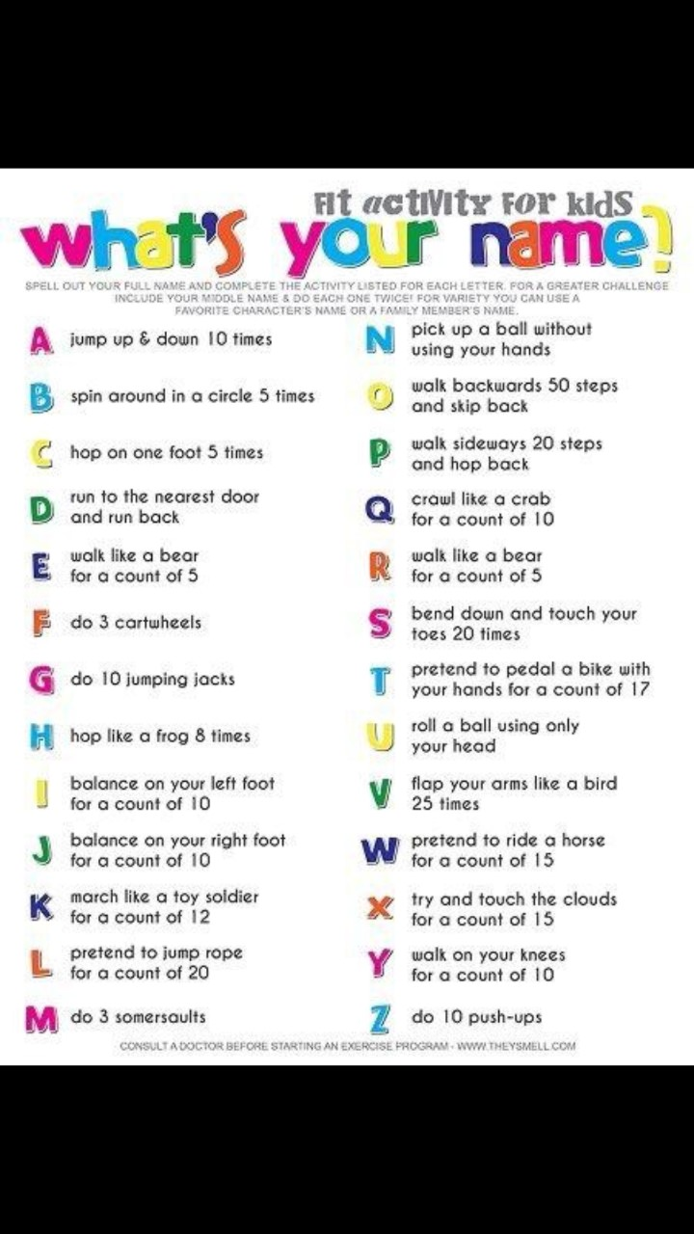

Tuesday 19th May
Gaeilge:
- Fuaimeanna agus Focail – aonad 29 page 88 – list 2 (learn next 4 words) complete C and D in workbook.
- An Aimsir Fháistineach (Future Tense) – So far this year, we have done lots of work on aimsir chaite (past tense) and aimsir láithreach (present tense) Now it’s time to learn about aimsir fháistineach(future tense) Watch this video, it explains the endings for leathan and caol. We are focusing this week on the faidh/fidh endings. Remember the endings – leathan – a, o, u = faidh. Caol – i, e = fidh
https://www.youtube.com/watch?v=cKOKiHOR07E
Now open the poster to show you an example of some briathra written in Aimsir Fháistineach
In the Assignment section, you will find todays assignment on Aimsir Fháistineach.

English:
- My Spelling Workbook - unit 16 – next 4 to learn – complete no.7 and continue with word search.
- Handwriting - complete second half of the page from yesterday in Go with the Flow

Geography:
- Map Skills – can you remember the 7 capitals you learned yesterday. Go on to the next 7 today on page 10 – Estonia to Ireland. Remember there will be a quiz on Friday open to both classes. Complete Activity B in your workbook.
Here is another capital cities game to try out
https://www.ducksters.com/games/europe_capital_cities_map_game.php
HistoryEnglish:
This week your task is to write about your experience of the coronavirus pandemic. I realise this may not sound like a history activity, but just think, in years to come kids just like you will be learning about this strange time in school. They will probably much prefer to hear your voice than the dry and dusty text of a schoolbook or some adult droning on with ‘interesting’ facts and figures. The link provided here will hopefully give you an idea of the kind of thing I am looking for. About an A4 page at least is how much I would like to see submitted. There is an assignment for this. You simply type your work into the space left for your answers. Or send a picture of your writing if you prefer.
https://slate.com/human-interest/2020/03/kids-diaries-coronavirus-pandemic.html

Science:
- STEM challenge - continue to work on this.

Maths:
Mathemagic Page 107.
Have a go at: Question 3 (a, b, c)
Also
Brain Teaser Test 73 (Múinteoir Claire’s class should have this done already, if not, complete it now)
There are assignments for these, please enter your answers there.
Art:
This week I would like to borrow an idea from Carrigaline Educate Together School. This link takes you to an Irish Examiner article about their project. I wonder can you too re-create the old (or modern) masterpieces of art?
https://www.irishexaminer.com/breakingnews/discover/from-carravagio-to-warhol-these-cork-kids-have-put-their-own-spin-on-arts-masterpieces-998928.html
This link takes you to an excellent source for these great paintings. Feel free to recreate a different painting that you really like. Where possible, when sending in an image of your efforts, include a picture of the painting you are imitating.
https://artclasscurator.com/a-year-of-art-appreciation-for-kids-52-artworks-your-child-should-know/
You have all week for this.

Wednesday 20th May
Gaeilge:
- Fuaimeanna agus Focail - aonad 29 – list 3 to learn – complete E and F in workbook
- An Aimsir Fháistineach – a little more practice. Remember the endings – leathan – a, o, u = faidh. Caol – i, e = fidh
You will find todays assignment in the Assignments section

English:
- My Spelling Workbook - unit 16 next 4 words – Complete No. 9 and word search if not already completed.
- Handwriting – go on to the next page in Go with the Flow and complete half the page.

Geography:
- Mapskills – Learn the next 7 E.U. countries and their capital cities on page 10, from Italy to Poland. Complete the Try at Home activity on page 11 of your workbook. If you keep up the practice the assignment will be a breeze.

Maths:
These are cost per item questions.
Mathemagic Page 108
Have a go at: Q 3, all parts. This video may help to explain.
There are assignments for these, please enter your answers there.

Art:
This week I would like to borrow an idea from Carrigaline Educate Together School. This link takes you to an Irish Examiner article about their project. I wonder can you too re-create the old (or modern) masterpieces of art?
https://www.irishexaminer.com/breakingnews/discover/from-carravagio-to-warhol-these-cork-kids-have-put-their-own-spin-on-arts-masterpieces-998928.html
This link takes you to an excellent source for these great paintings. Feel free to recreate a different painting that you really like. Where possible, when sending in an image of your efforts, include a picture of the painting you are imitating.
https://artclasscurator.com/a-year-of-art-appreciation-for-kids-52-artworks-your-child-should-know/
You have all week for this (and more).

History/English:
This week your task is to write about your experience of the coronavirus pandemic. I realise this may not sound like a history activity, but just think, in years to come kids just like you will be learning about this strange time in school. They will probably much prefer to hear your voice than the dry and dusty text of a schoolbook or some adult droning on with ‘interesting’ facts and figures. The link provided here will hopefully give you an idea of the kind of thing I am looking for. About an A4 page at least is how much I would like to see submitted. There is an assignment for this. You simply type your work into the space left for your answers. Or send a picture of your writing if you prefer.
https://slate.com/human-interest/2020/03/kids-diaries-coronavirus-pandemic.html

Science
- STEM challenge - continue working on your challenge

Thursday 21st May
Gaeilge:
- Fuaimeanna agus Focail - aonad 29 – list 4 to learn – complete G and H in workbook

English:
- My Spelling workbook - unit 16 – next 4 words to learn – complete No. 10 in workbook. All written activities for unit 16 should now be complete.
- Handwriting - complete second half of the page from yesterday in Go with the Flow

Maths:
These are value for money questions
Mathemagic Page 109
Have a go at Q 2 & 3, all parts. This video may help to explain.
Also
Brain Teaser Test 74(Múinteoir Claire’s class should have this already done)
There are assignments for these, please enter your answers there.

Art:
This week I would like to borrow an idea from Carrigaline Educate Together School. This link takes you to an Irish Examiner article about their project. I wonder can you too re-create the old (or modern) masterpieces of art?
https://www.irishexaminer.com/breakingnews/discover/from-carravagio-to-warhol-these-cork-kids-have-put-their-own-spin-on-arts-masterpieces-998928.html
This link takes you to an excellent source for these great paintings. Feel free to recreate a different painting that you really like. Where possible, when sending in an image of your efforts, include a picture of the painting you are imitating.
https://artclasscurator.com/a-year-of-art-appreciation-for-kids-52-artworks-your-child-should-know/
You have all week for this.
History/English:
This week your task is to write about your experience of the coronavirus pandemic. I realise this may not sound like a history activity, but just think, in years to come kids just like you will be learning about this strange time in school. They will probably much prefer to hear your voice than the dry and dusty text of a schoolbook or some adult droning on with ‘interesting’ facts and figures. The link provided here will hopefully give you an idea of the kind of thing I am looking for. About an A4 page at least is how much I would like to see submitted. There is an assignment for this. You simply type your work into the space left for your answers. Or send a picture of your writing if you prefer.

https://slate.com/human-interest/2020/03/kids-diaries-coronavirus-pandemic.html

Science:
- Science – continue your STEM activity

Friday 22nd May
Gaeilge:
- Fuaimeanna agus Focail - revise all 16 words from aonad 29 before completing the assignment on Teams.

English:
- My Spelling Workbook - revise all 16 words from unit 16 –from “fabulous” to “close” before completing the assignment on Teams.
Geography:
- Revise all E.U countries and their capitals before completing the assignment on Teams. The assignment is for both classes.
History:
Don’t forget to submit your History by 6pm this evening.

Science:
- Science – upload a photo of your STEM challenge completed

Maths:
Make sure all your maths work has been submitted.
Make sure you have read the feedback given to you.

Art:
Have you submitted your art?

