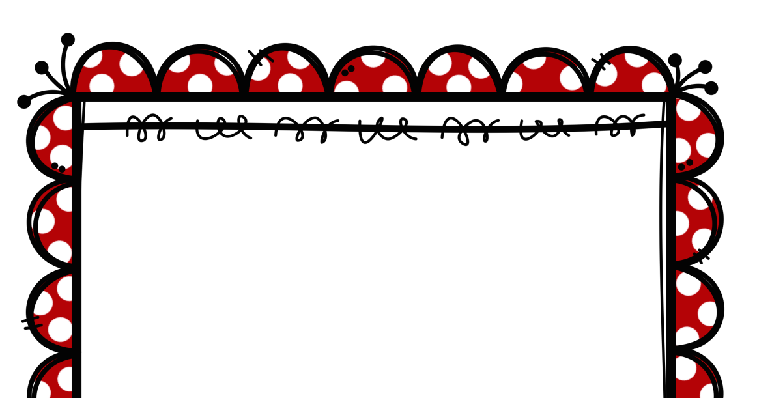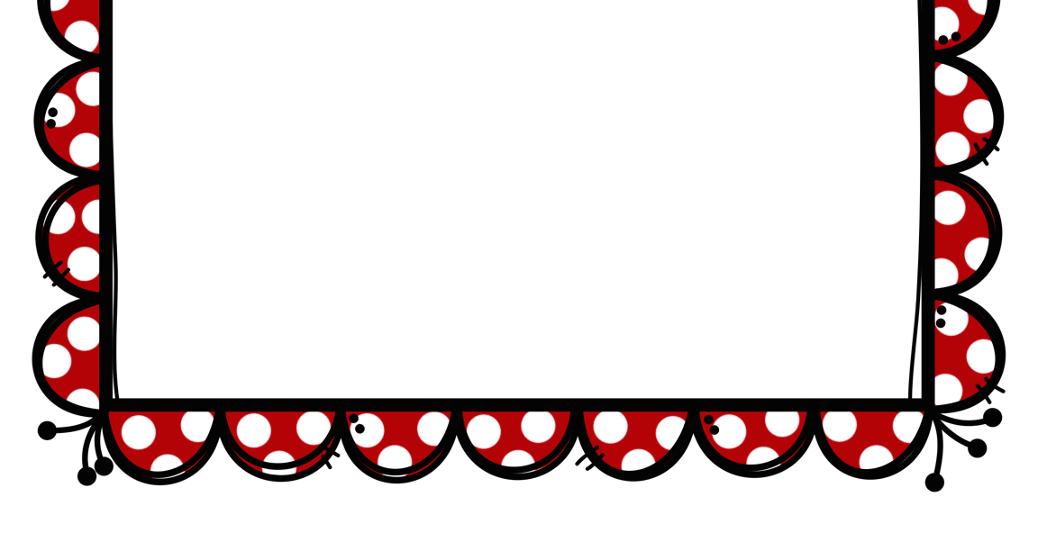

10 days of STEM
Challenges
Week 2

Suggested STEM Materials

- 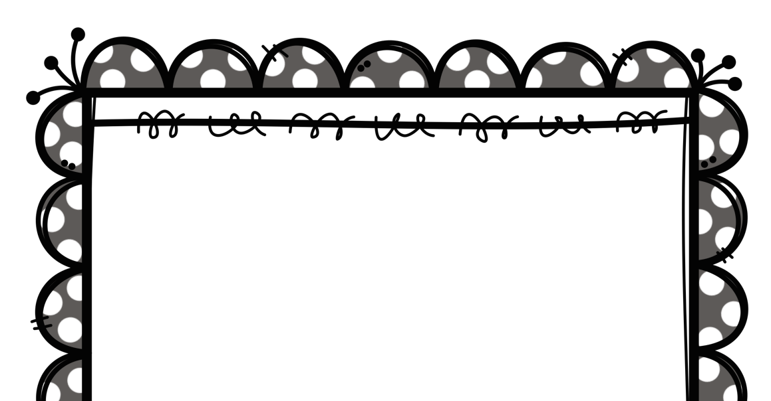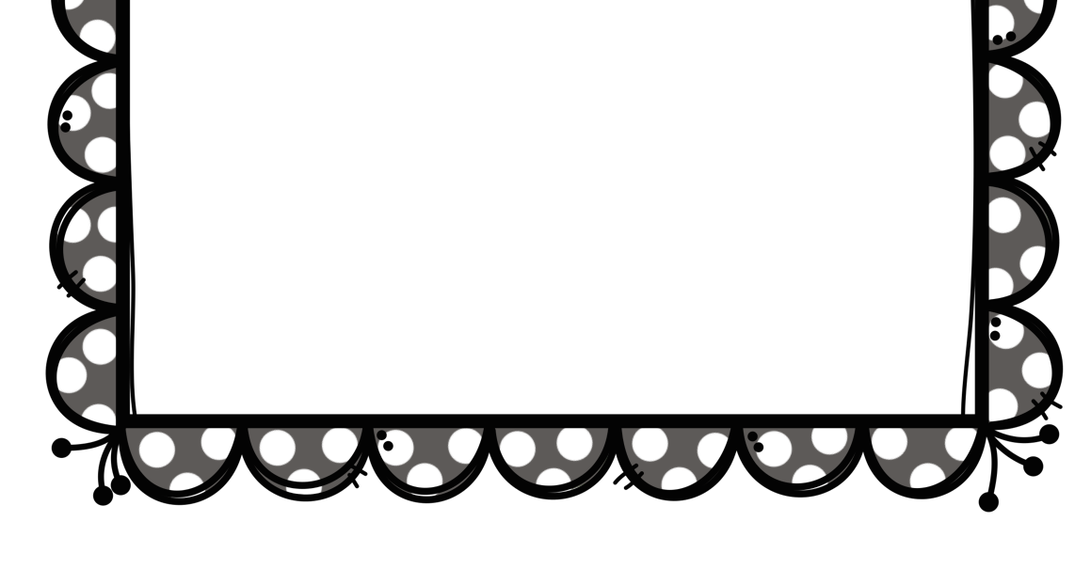Lego
- Jenga Blocks
- K’nex
- Cocktail sticks
- Mini marshmallows
- Play Dough
- Paper or plastic cups
- Playing cards
- Dominoes
- Lollipop sticks
- Pegs
- Paper plates
- Newspaper
- Pipe cleaners
- Straws
- Empty toilet rolls
- Paper and card
- Sellotape /masking tape
- Glue
- Cardboard boxes
- Egg cartons
- Paper clips
- Tin foil
- String
- Elastic Bands
- Ribbon
- Bottle tops

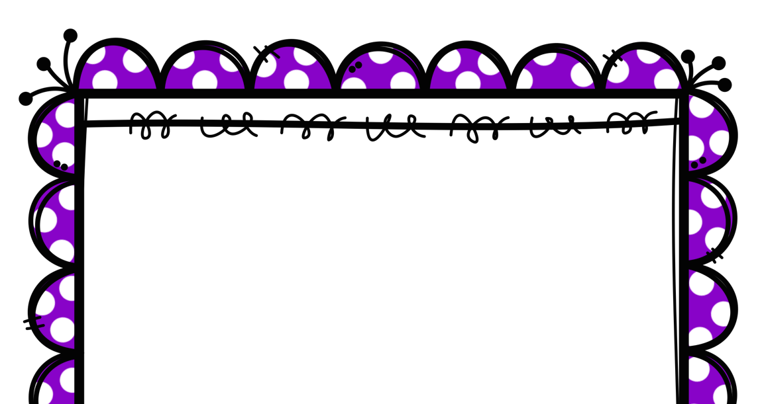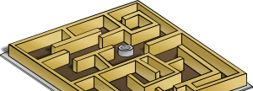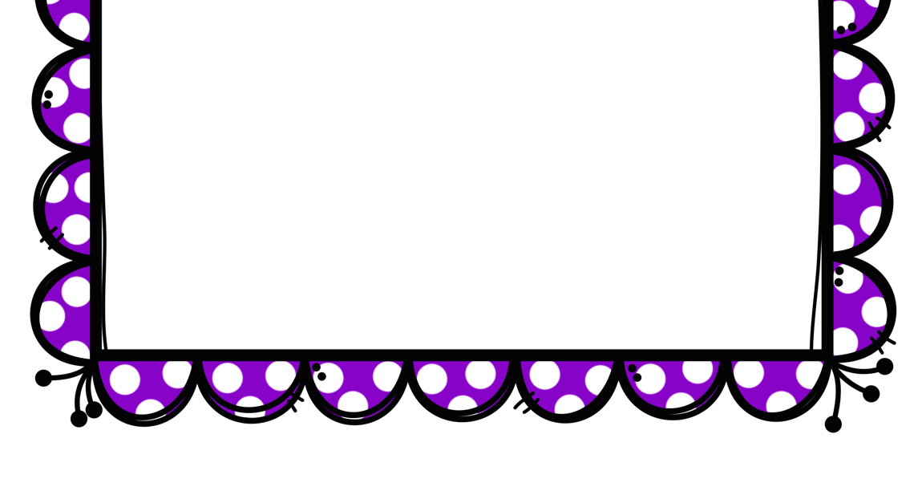

STEM Challenge Day 6
Make a marble maze.

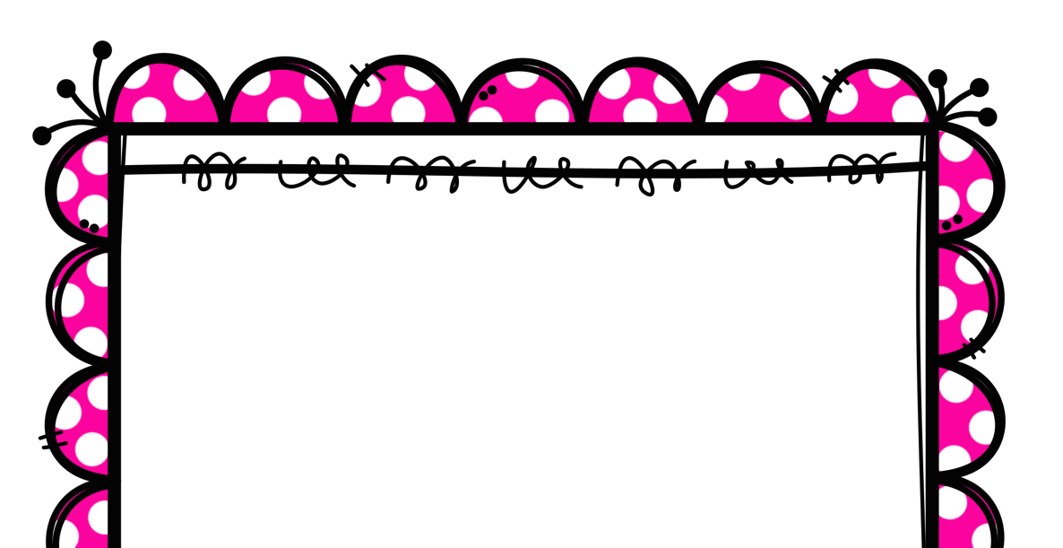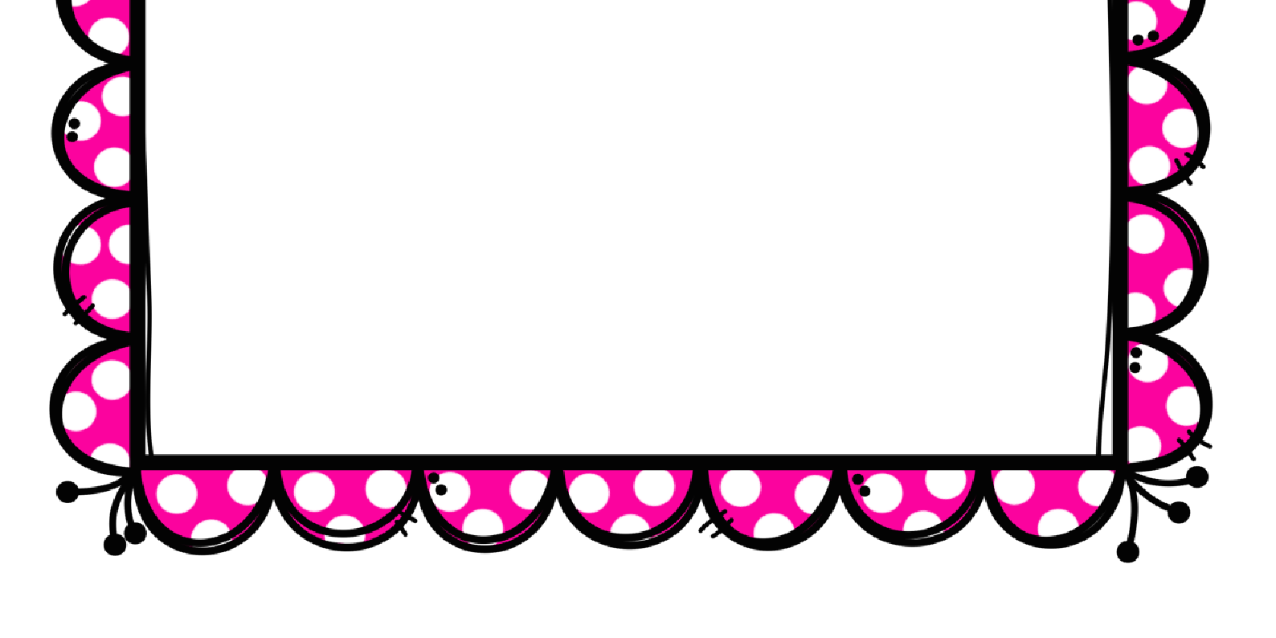

STEM Challenge Day 7
Build a bridge that can hold some toy cars.

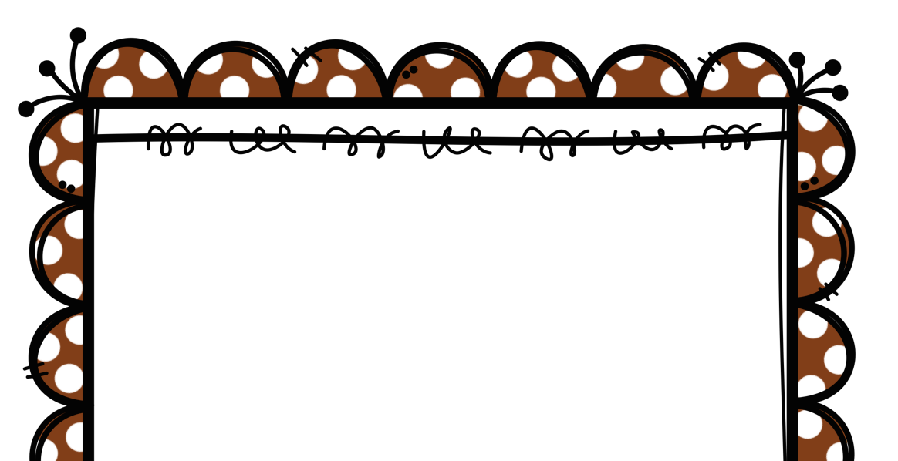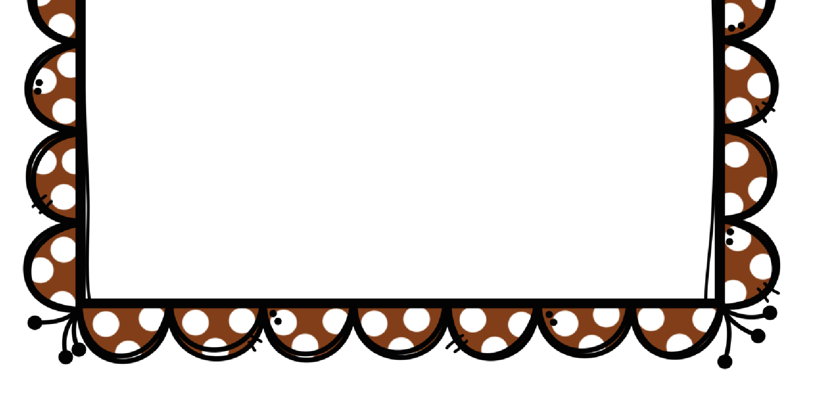

STEM Challenge Day 8
Make a robot from recycled materials.

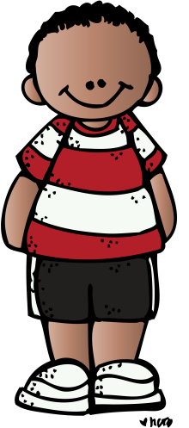

STEM Challenge Day 9
Build a tower as tall as yourself!

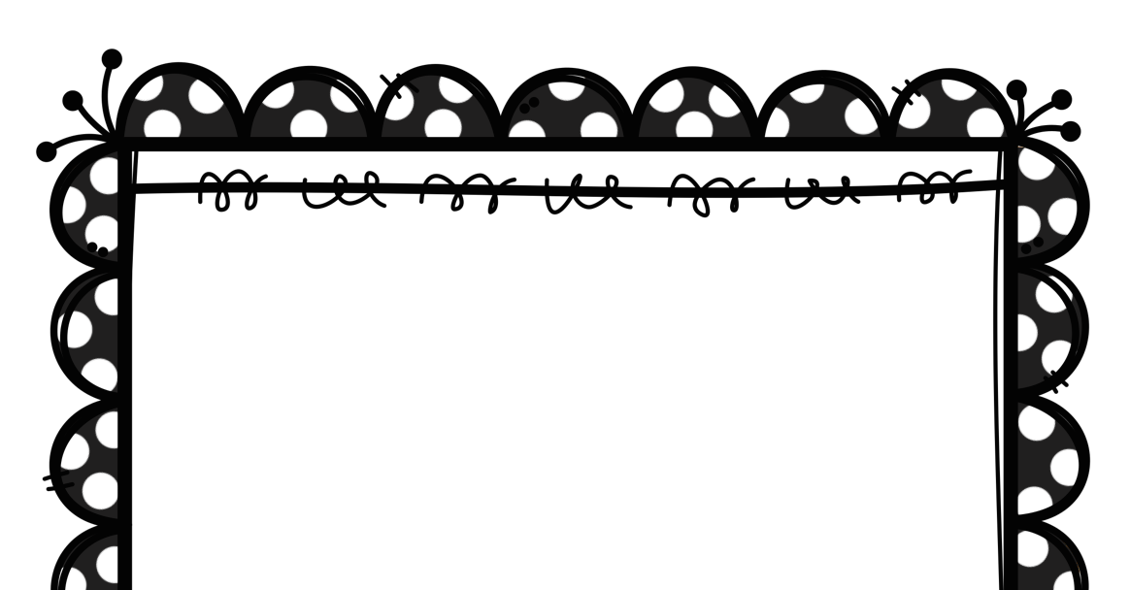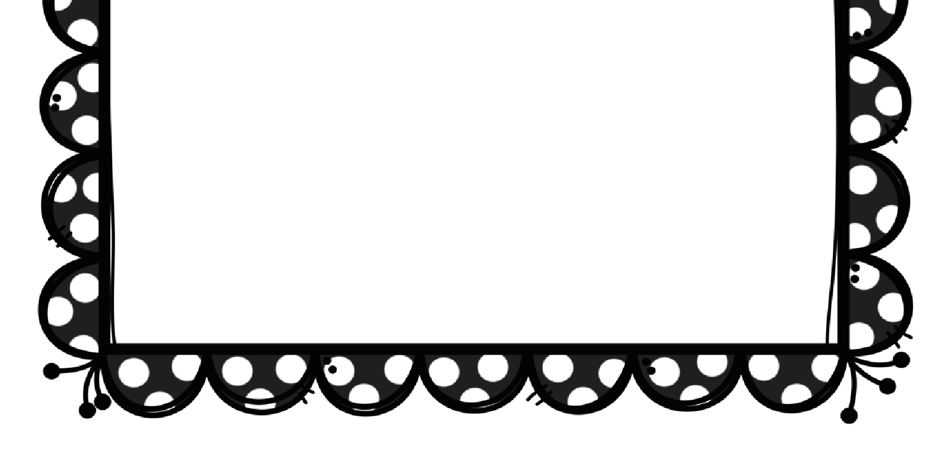

STEM Challenge Day 10
Make a paper
aeroplane that can fly at least 2 metres.

