Dear Parents/ Guardians,
I hope you are all keeping well and taking some time to enjoy the beautiful weather we have been having. Thank you for your great correspondence again this week, I really appreciate hearing from all the boys and girls and receiving excellent samples of their great work.
In this document you will find the suggested activities and work for next week, 2nd June – 5th June (please note, Monday is not included as it is a bank holiday). I wish to stress, this document is only a guide and we do not want you to be under pressure. Complete whatever amount of work is feasible with your child.
Please continue to send samples of the pupils great work to nicholasm2008@gmail.com or mnicholas@ballinaprimaryschool.com . If you have any queries about the work, don’t hesitate to send me an email at any stage also.

English
- ‘Minibeasts’ is our theme for the next two weeks. As the weather is set to be very nice, we are encouraging pupils to enjoy the outdoors and explore their garden areas.
- Structured Writing Activity- Pupils may wish to engage in a procedural writing activity for this week, ‘Going on a minibeast hunt’. Pupils can write about specific equipment they may have at home such as; a magnifying glass, a small tray, or a plastic cup may be used as a ‘pooter’ for collecting some insects and a small plastic shovel. Pupils may decide to write about the process of examining some insects or the soil around their garden. Three or four sentences are sufficient and pupils can add a picture of their hunt when they have completed their writing activity.
- Modified list of words to be read to pupils for this week, pupils should aim to read two or three new words independently every week.
Examples: ant, ladybird, spider, slug, worm, butterfly, woodlouse, soil, flowers, pooter, magnifying glass, snail.
Oral Language and Reading based on the theme of ‘minibeasts’
- This week we are encouraging you to have a look at some books linked to the theme of ‘minibeasts’, we will include a few suitable suggestions in this list and we also encourage you to look up the YouTube clips for these stories, as they are read aloud.
- ‘Superworm’ by Julia Donaldson
- ‘Mad about Minibeasts!’ by Giles Andreae
- ‘What the ladybird heard’ by Julia Donaldson
- ‘Spinderella’ by Julia Donaldson
- ‘Twist and Hop, minibeast bop’, by Tony Mitton
- Continue to include books in the previous blank reading diary when completed.
- Two new tricky words for this week- ‘new, would’. Please keep up revision of all previous ‘Tricky words’.
- Phonics- This week we will be moving on to revision of the sounds ‘sh, ch, th and wh’. Pupils will give each sound their own choice of colour and proceed to colour code the words, page 56 in workbook. On page 57, pupils will practice reading the words independently, paying special attention to the new sounds. Some pupils will work on page 58 in ‘Just Phonics’ continuing to revise ‘sh, ch, th and wh’ sounds. Pupils will also look the ‘_ash’ sound on page 59 this week, focusing on words such as ‘cash, lash, mash and rash’.
- Handwriting- On page 62, pupils focus on the ‘full stop, question mark and exclamation mark’ to be used when required. Pupils will unjumble the sentences and remember to look out for the capital letter at the start of each sentence.
- Please see separate links document for more ideas to develop English learning this week.
Maths
- This week we are continuing to focus on the topic of ‘money’. Pupils should be able to recognise, sort and name coins up to 20c. Pupils should also be able to select the appropriate coins in shopping activities and solve practical problems using coins up to 10c.
- On page 108, pupils will colour the correct amount of coins to match the price of the fruit. On page 109, there are a mixture of items, pupils will continue to colour the appropriate amount of coins to ‘purchase’ the items.
- Please use concrete coins or cut out coins as much as possible for pupils to practice identifying and matching various amounts.
- This week, we will also focus on recognsing/ writing numbers before, after and between a specified number within 10, including 0.
- On pages 110 and 111, pupils will continue to practice the numbers that come after and before the specified numbers listed.
- If you have some cubes/ lego at home, we would encourage you to keep practicing the appropriate maths language, such as ‘what colour cube comes before/ after / or in between certain coloured cubes or lego bricks?’.

SESE- NB please note, all SESE topics cover a two-week period.
Linked to theme of ‘Minibeasts’.
Science – This week we are encouraging pupils to go on a ‘minibeast hunt’, pupils may gather suitable equipment such as the items listed above in the ‘English section’. In the separate links document that follows this plan, you will find sample grids which pupils may fill out according to their findings. Pupils may come across a ladybird/ ant/ spider / worm or butterfly.
History- We are focusing on story sequencing this week. We are suggesting that pupils will focus on the Julia Donaldson story, ‘What the ladybird heard’. Here is the YouTube clip, as this story is read aloud. https://www.youtube.com/watch?v=Eu9mPX7DuLA
In their copies, pupils may write about what happened first/ next and last. Pupils may also draw pictures of the animals and the change of setting in their copies.
Geography- Linked to the theme of the ‘minibeast hunt’, in science, we are encouraging pupils to explore a ‘soil environment’ this week. In the separate ‘links document’ for this week, you will find the worksheet linked to this topic. Pupils will decide what equipment is needed for exploring a soil environment. They will proceed to draw two animals they hope to find and sort what items they found at the end into three different categories.
Art-
This week we would like pupils to focus on drawing a suitable habitat for a minibeast. They may wish to use crayons/ markers or paint. They may decide to draw the habitat for a ladybird/ worm. Pupils may also design a collage and utilise ‘junk art’, to design this habitat. Alternatively, this week, pupils may wish to make a ‘diorama minibeast habitat’, see images below for some great ideas. The main resource pupils will need, is a small shoe box or empty cardboard box, pupils might also like to include some stones/ soil/ pebbles they have collected.
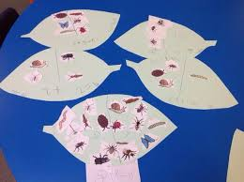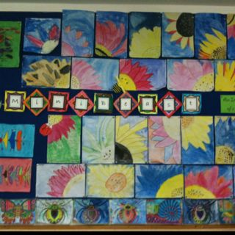
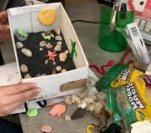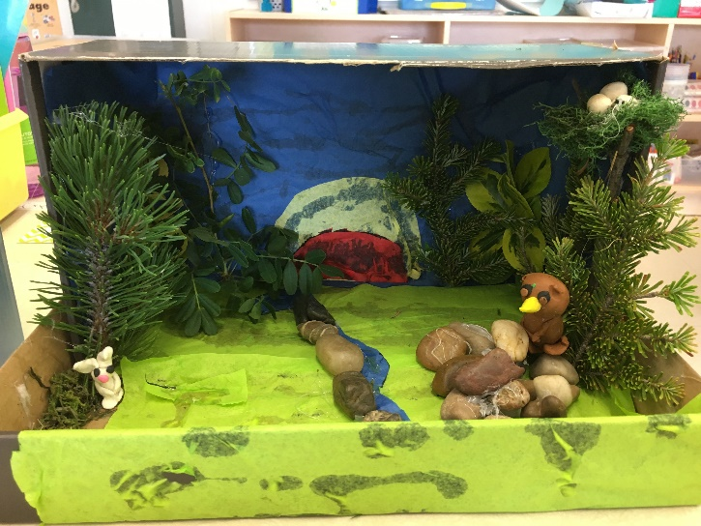

PE-
- We continue to encourage pupils to enjoy the outdoors and stay active during their ‘minbeast hunts’. They may also set a challenge for a ‘toy minibeast’ and the pupil will guide them through this active challenge.
- Joe Wicks, has some excellent daily challenges https://www.youtube.com/channel/UCAxW1XT0iEJo0TYlRfn6rYQ
- ‘Happiful’ website also has excellent website links to daily active activities, including ‘Zumba/ Go Noodle/ Cosmic Kids Yoga/ iMoves’, https://happiful.com/10-virtual-pe-lessons-your-kids-will-love/
- See separate ‘links document’ for more PE activities.

Gaeilge:
- Topic for this week – Revision of topics covered to date, also including Irish colours.
- On page 100, I will attach the instructions followed by the translations to help you to complete this activity with pupils.
- ‘Cuirigí méar ar an éan. Dathaígí an t-éan donn. (Put your finger on the bird, colour the bird brown)
- Cuirigí méar ar an teach. Dathaígí an teach gorm. (Put your finger on the house, colour the house blue)
- Cuirigí méar ar an uachtar reoite. Dathaígí an t-uachtar reoite corcra. (Put your finger on the ice -cream, colour the ice-cream purple)
- Cuirigí méar ar an gcaisleán gainimh. Dathaígí an caisleán gainimh oráiste. (Put your finger on the sandcastle, colour the sandcastle orange)
- Cuirigí méar ar an spád. Dathaígí an spád glas. (Put your finger on the spade, colour the spade green)
- Cuirigí méar ar an mbád. Dathaígí an bád dubh. (Put your finger on the boat, colour the boat black)
- Cuirigí méar ar an muc. Dathaígí an mhuc bándearg. (Put your finger on the pig, colour the pig pink)
- Cuirigí méar ar an gcapall. Dathaígí an capall donn. (Put your finger on the horse, colour the horse brown)
- Cuirigí méar ar Thafaí atá ag léim. Dathaígí Tafaí oráiste. (Put your finger on Tafai jumping, colour Tafai orange)
- Cuirigí méar ar an líreacán. Dathaígí an líreacán dearg. (Put your finger on the lollipop, colour the lollipop red)
- Cuirigí méar ar an tseacláid. Dathaígí an tseacláid donn. (Put your finger on the chocolate, colour the chocolate brown)
- Cuirigí méar ar an liathróid chispheile. Dathaígí an liathróid chispheile buí. (Put your finger on the basketball, colour the basketball yellow).
- On the top half of page 101, pupils place the correct letter beside each word.
- On the bottom half of page 101, pupils will talk through the activities Seán is doing, join the dots and colour the pictures.
Religion:
- Theme for this week ‘Baptism- John the Baptist’.
- https://app.growinlove.ie/en/user/lesson-resources/31This week pupils will explore the video linked to ‘John the Baptist’ on the Grow in Love website, this also includes ‘John the Baptist’ colouring page, along with exploring how we can care for water and show our love for God.
- On page 54 of the workbook, pupils will draw the people who wanted to be baptised by John.
- On page 55, pupils will focus on ‘what John told the people to do’. They will focus on being good, kind and honest.
See below for suggested timetable of work to be completed this week. You will also find a separate document with links/ suggestions to aid learning in all of the above topics.

Tuesday | Wednesday | Thursday | Friday
Maths- BAM pg 108 | Eng- Just Phonics  Workbook pg 56 or 58 | Handwriting- pg 62 | Maths- BAM pg 111
Eng- Structured Writing Activity ‘Going on a Minibeast Hunt’ | Religion –Grow in Love pg 54 | Maths- BAM pg 110 | English- Just Phonics Workbook pg 57 or 59
Gaeilge- Abair Liom pg 100 | SESE Science/ Geography – See above suggested activities | Art- Minibeast Creations | Religion- Workbook pg 55
Revise ‘two new tricky words’ and last week’s tricky words. Reading practice ‘Minibeast themed books’. | Maths- BAM pg 109 | Gaeilge- Abair Liom, top half of pg 101 | SESE History- See above suggestion/ PE Activities

*BAM- Busy At Maths
*Suggested timetable for this week including all activities detailed in the above section.

