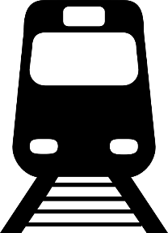
Reading a Timetable Use the timetable below to answer the questions.

Morning Service
Montville to Clapham
Monday to Friday
Montville | 0524 | 0554 | 0624 | 0654 | 0724
Burleigh | 0546 | 0616 | 0646 | 0716 | 0724
Green Lake | 0553 | 0623 | 0653 | 0723 | 0753
Charlie St | 0602 | 0632 | 0702 | 0732 | 0802
Woodford | 0608 | 0638 | 0708 | 0738 | 0808
Newark | 0620 | 0650 | 0720 | 0750 | 0820
Dover St | 0627 | 0657 | 0727 | 0757 | 0827
Clapham | 0645 | 0715 | 0745 | 0815 | 0845

Afternoon Service
Montville to Clapham
Monday to Friday
Montville | 1432 | 1502 | 1532 | 1602
Burleigh | 1454 | 1524 | 1554 | 1624
Green Lake | 1501 | 1531 | 1601 | 1631
Charlie St | 1510 | --- | 1610 | 1640
Woodford | 1516 | 1544 | 1616 | 1646
Newark | 1528 | 1556 | --- | 1658
Dover St | 1535 | 1603 | 1633 | 1705
Clapham | 1553 | 1621 | 1651 | 1723

- What time does the last train of the morning leave Montville?

- Lisa needs to get from Green Lake to Woodford in the morning. How long will the journey take?

- Dan needs to get to Clapham as early as he can. What time is the earliest time he can get there by train?

- Mary lives in Burleigh and has a meeting in Newark at 7:45am. Which train should she get?

- Graham catches the 1502 train from Montville and gets off at Dover St. How many stops does the train make along the way?

6: How long is the trip between Montville and Burleigh?

7: Montville to Clapham in the afternoon does not take as much time as the same journey in the afternoon. Why?

