Date | Monday | Tuesday | Wednesday | Thursday | Friday
8th-12th June | STEAM  Can you design something from tinfoil?? | ART/CREATIVE  Find a volunteer (friend, parent or a sibling) and stack 5 cheerios (oreo cookie, gummy bears or anything you prefer) on his nose. Take a picture. Extra points if you do this while the ”volunteer” is sleeping. | PE  Create an Obstacle Course  - Upload a video or pictures onto Teams  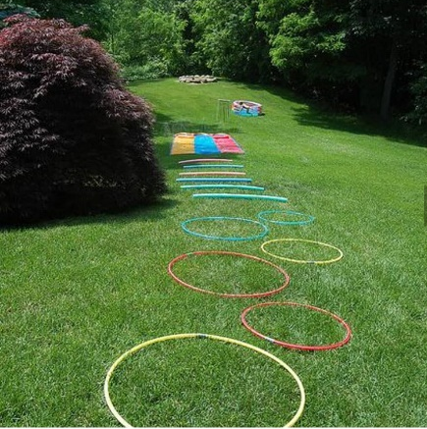 | NATURE  Name Scavenger Hunt  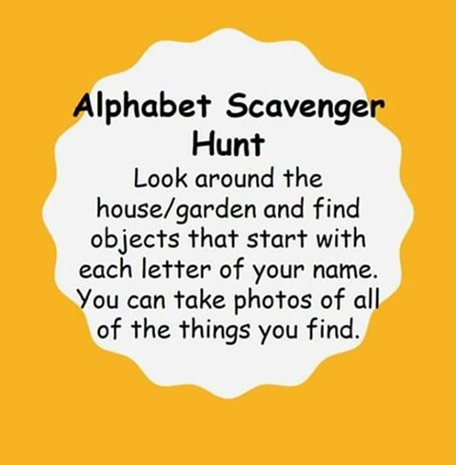 | Upload pictures onto Teams or through email.

