Date | Monday | Tuesday | Wednesday | Thursday | Friday
15th-20th June | ART/CREATIVE  Build a reading fort. Make it comfy and cosy and read for 15 minutes | PE  Fitness Spelling Challenge  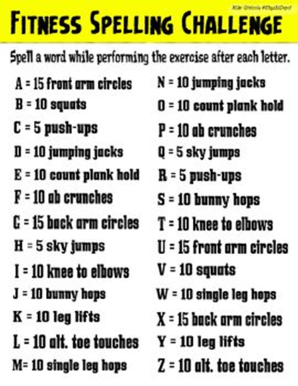 | NATURE  Shadow design: can you draw around the shadows that your toys make?  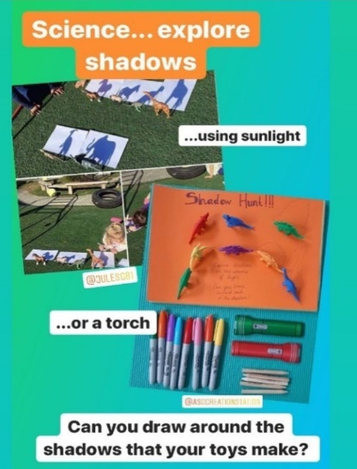 | STEAM  Can you make a seesaw zipline using any materials ?  